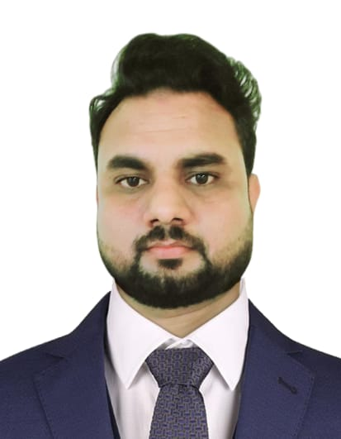Raihan Ansari

Mobile: **+97450647454**

Email: [**ansariraihan28@gmail.com**](mailto:ansariraihan28@gmail.com)

# CAREER OBJECTIVE

To achieve professional excellence in any above-mentioned field that provide me with opportunities to fully utilize and develop my knowledge, skills, information, and education. I am easily motivated, confident, honest, and dedicated to my job. And good ethics.

# ACADEMIC QUALIFICATION:

* SLC from Multiple Creative Academy.
* Intermediate (+2) from Sunsari Multiple Campus.

**Note: I have got Qatar Driving Licence (Light)**

# PROFESSIONAL EXPERIENCE:

1. Valet driver at QDVP PQSC (Mawaqif Qatar) Service period – 27th Nov 2023 to 30th

Sept 2024

1. Delivery Driver (TALABAT QATAR) Service period - Jan 2023 to Sep 2023
2. VIP Driver at PEACE RENT A CAR (FIFA Project Qatar) Service period – 4 months
3. Delivery Driver at GULF CATERING CO. (Saudi Arabia) Service period 2017-2021

**Qualities:**

* Much experience in driving light as well as heavy vehicle.
* Much Experience in handling large number of customers.
* Strong Ability to client handling and follow-up them.
* Strong ability to install and repair basic problems
* Ability to work under pressure.

**IT SKILLS & COMPETENCIES:**

* Good at Ms. Outlook, email application
* Good at Ms. Office (Word, Excel)
* Strong communication and time management skills
* Able to communicate in English, Arabic, Nepali and Hindi with positive attitude  Fast learning ability

**PERSONAL DETAILS:**

Name: Raihan Ansari

Recent Address: Al Mansoura Doha

Date of Birth: 1993-01-07

Gender: Male

Marital Status: Married

Nationality: Nepali

Passport No: BA0098345

NOC: Yes

I hereby certify that the above information is true and correct.