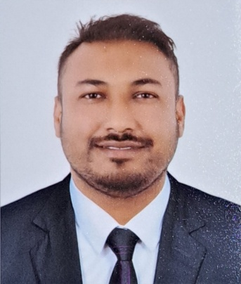**CURRICULUM VITAE**

**Name : - Md Abdul Salam**

**Contact : - +974-31380556**

**Address : - Saptari, Nepal**

**Email : -** [**Mass74009362@gmail.com**](mailto:Mass74009362@gmail.com)

**Objective: -**

To Work in A Challenging And Continuously Growing Environment Where My Skills Are Utilized Effectively Which Provides Me With The Platform For Growing With The Organization Leading To A Mutually Beneficial Association.

**Applying For : - Light Driver**

**Personal Profile: -**

Name : - Md Abdul Salam

Address : - Pato-6, Saptari, Nepal

Date Of Birth : - 03-10-1992

Nationality : - Nepali

Gender : - Male

Marital Status : - Married

Religion : - Muslim

**Passport Details: -**

Passport Number : - PA0312129

Date Of Issue : - 28-04-2022

Date Of Validity : - 27-04-2032

Place Of Issue : - Mofa, Department of Passport(NEPAL)

**Language Details**: -

English : - Excellent

Arabic : - Good

Hindi : - Excellent

Nepali : - Excellent

Urdu : - Excellent

Maithili : - Excellent

**Academic Qualification: -**

|  |  |  |  |  |  |
| --- | --- | --- | --- | --- | --- |
| Sn | Level | Board\Institute | Pass Year | Div. | Remarks |
| 1 | SLC Board of Nepal | Shree Janta Madhyamic Secondary School KataiyaFattepur | 2011(2067 B.S) | 2nd |  |
| 2 | PCA 7 Months | Laxmi Advance Computer Institute | 2068-01-01bs-To- 2068-07-30bs | 1st |  |

**Working Experience: -**

* 12 Years Is The Total Experience In Driving In Qatar.
* Worked As A Driver In Al Hikma Engineering Co. Qatar From 23rd Oct 2013 To 20th Jan 2018(4years).
* Worked As light driver In Qatar National Import & Export W.L.L. Qatar(2018 Jan 20 to 2019 may).
* Working As AOffice Assistant In ARB NYBAL LTNZYFAT WALDYAFHQatar. From October 2019 Till Present.

**Computer Skills: -**

* Basic Windows
* MS-Word
* Power Point
* MS-Excel
* Multimedia
* Email/Internet Etc.

**Personal: -**

* Excellent Organizational Skills.
* Good Oral and Written Communication Skills.
* Pro-Active And Self-Motivated

**Declaration: -**

I Do Here Certify That The Information And Details Are Accurate And True To Best Of My Knowledge

SINCERLELY,

MD ABDUL SALAM

