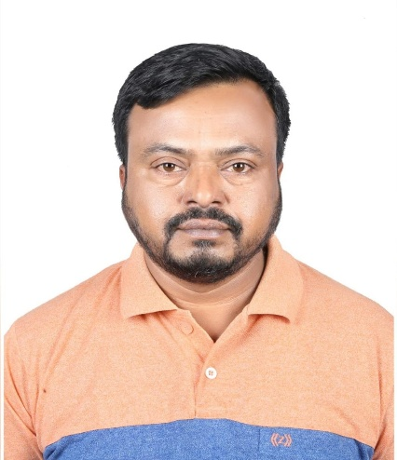***CURRICULUM VITAE***

***OF***

***ALAMGIR HOSSAIN***

Mobile: +974-70606618 (Self)

E-mail: [alamgir­_doha@yahoo.com](mailto:alamgir_doha@yahoo.com)

***Apply for: Heavy Driver.***

***CARRIER OBJECTIVE:***

* To accomplish a challenging career for using my interpersonal skills and acquired.

***PERSONAL DETAILS:***

Date of Birth : 22-05-1978

Father’s Name : Abdul Mannan

Nationality : Bangladeshi

Religion : Islam

Gender : Male

Marital Status : Married

**Passport No. : EJ0843794**

Date of Issue : 07 NOV 2021

Date of expiry : 06 NOV 2026

**Driving License No. : 27805002074 (Qatar)**

First Issue : 13/09/2007

Validity : 25/08/2029

***PRESENT ADDRESS***

* Street 368, Zone 56, Building 4, Unit 8, Ain Khalid, Doha, Qatar.

***PERMANENT ADDRESS***

* Village: Nikla Dari Para, Post: Nikla, Police Station: Bhuapur, Dist: Tangail.

***EDUCATIONAL QUALIFICATION:***

* Class Nine Passed

***LANGUAGE KNOWN***

* Bengali, Hindi, English & Arabic.

***WORK EXPERIENCE:***

* Three years’ experience as a “**Trailer Driver**” in **Star Line International Transport Company**. in Kuwait (2004 to 2007).
* Mowasalat Transport Company (KARWA) in Doha, Qatar as a “Heavy Bus Driver”, from 11 July 2007 to 06 April 2017.
* Marco Trading & Contacting Wll. Company in Doha Qatar as a Heavy Vehicle Driver from 14 September 2019 to 30 June 2021.
* At present I am serving in **Deliopolis WLL Company**. Doha Qatar as a Heavy Vehicle (Delivery Van) Driver From 1st July September 2021 to till date

***HOBBIES***

* Traveling, Playing cricket, Reading Books, Web Browsing, Organizing, etc.

Date: Signature