CHIEF WARRANT OFFICER
(RETD)
GHULAM MUJTABA

Diploma of Associate Engineer
(Automobile and Diesel Technology)

SUMMARY
25 years’ experience with Pakistan Air Force as an associate engineer in Automobile and Diesel Technology.
Expert in repair and maintenance of Toyota, Honda, Suzuki, Isuzu, Hino MAN, Volvo vehicles, Specialist, Operational vehicles, Military vehicles and Light / Heavy Diesel Generators. Proficient in Managerial, Logistics and MT Fleet Supervision.
EXPERTISE and SKILLSET
Through VOCATIONAL TRAINING
Operations Repair & Maintenance of Vehicle and Aero space Ground Support Equipment’s | Skill Enhancement Program Supervisors & Management Course
Quality Assurance (QA) Course for Supervisors | AD EQPT/ MPDR Hydraulic System Field Maintenance Course
Basic Driving Course | Electronic Fuel Injection System
Balloon Barrage System Course

Through SUPERVISORY TRAINING
Senior Non-Commissioned Officer Disciplinary Course | Management and administration
Military Leadership & Command Course

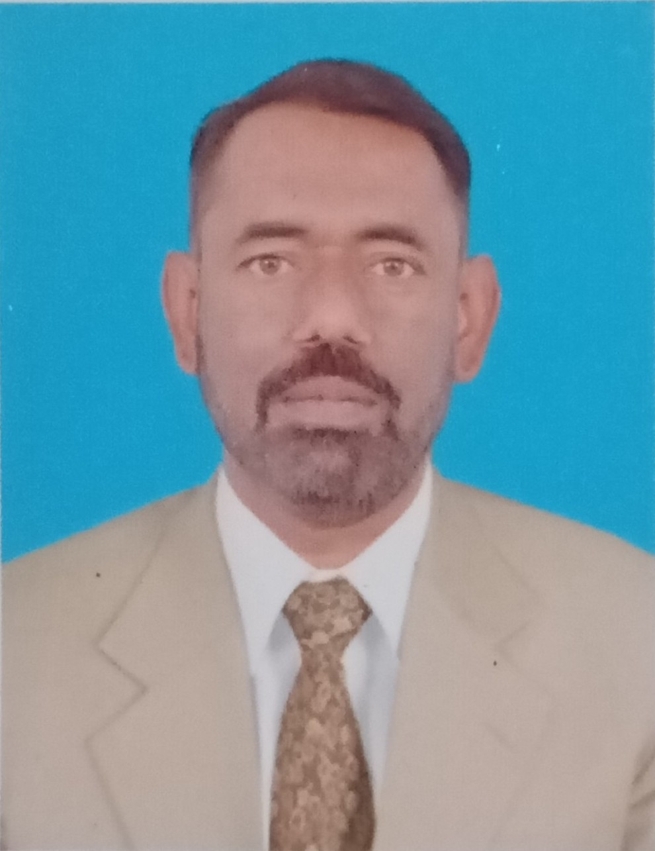
Personal Info
Mobile
+92 3226733661
WhatsApp
+92 3335915122
Shahmirhassan42@gmail.com
Address
Vill & P.O Bhaun Tehsil Kalar Kahar
District Chakwal, Pakistan
D.O.B
14 February 1980
Education and Languages
Languages
English, Urdu, Punjabi
Education
Diploma (DAE)
Pak Air Force Academy (2000-2001)

SSC (Secondary School)
Govt High school Bhaun, Chakwal
(1996- 1997)
Hobbies


Technical Level

Maintain repair logs and documentations, all preventive and corrective maintenance of all types of Toyota, Honda, Hino, Isuzu, Suzuki, Military vehicles, Operational and specialist vehicles and Diesel Generators

Read and interpret maintenance manuals of all types of international vehicles such as Toyota, Honda, Isuzu, Mercedes Benz to determine the feasibility and method of repairing or replacing of malfunctioning or defective components

Replace or repair worn, defective or damaged components, using hand tools, gauges and testing equipment

Examine and inspect mechanical components to locate cracks, breaks, or leaks

Personnel safety and workshop safety

Inspect completed work to certify that maintenance meets highest standard

Supervisory Level

Supervised a major MT Fleet diagnostic and Maintenance.

Trainer of junior technicians and design their professional development journey

Maintain and keep operational the Mechanized Warfare

Supervised Mechanical Transport (MT) operations.

Correspondence with HQs and other departments.

Good Management of material and human resources.

Good in office management.

Good in Crises Control Management

Good in CCTV camera supervision

