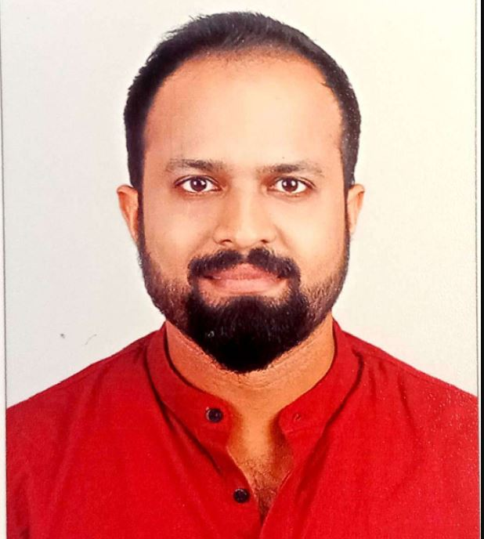  DENNY  DAVIS  Senior Genset Technician /Team Lead  Nationality: INDIAN  Contact  Address  Building no 25, Zone 56,  Street 377, Ain Khaled, Al Rayyan, Qatar  Phone  +974 33803263,  +974 66012822  E-mail  denny.dvs@gmail.com  denny.davis00@gmail.com  Permanent Address:  Kollannur House,  Gandhi Nagar,  R.V Puram (P.O),  Thrissur , PIN 680631,  Kerala  Skills  :  MS Word:  MS Power Point:  MS Excel:  Valid Qatar Driving License  (Manual):  Languages Known:  English:  Arabic  Hindi:  Malayalam:  Tamil  :  : | Seeking a position to utilize skills and ability in the field of diesel power generation, while being resourceful innovative and flexible to blend the technical and professional knowledge to achieve organizational and personal goals.  CORE COMPETENCIES:  - Applying technical expertise.  - Analysis and decision making.  - Informing and communicating.  - Teamwork and collaboration.  - Building relationships and networking.  - Continuous professional development.  - Flexibility and adapting to change  Work History  GENSET TECHNICIAN/ TEAM LEAD  (13-04-2014 TO TILL DATE )  TOPTEC TECHNOLOGY & TRADING CO. WLL, QATAR  JOB RESPONSIBILITIES: -  - Conduct on-site visits to evaluate installation conditions and gather technical data. Create customized proposals including generator sizing, installation plans, and cost estimates.  - Collaborate with engineer’s teams to design tailored power solutions including synchronization, ATS and parallel operation systems. Assess customer power generation needs based on factors like load, application and site conditions.  - Using I-COMMET software for Cooper engines with ECU. Fault finding and diagnosis of engine troubles by analysing fault codes. Identifying issues with ECM, ECM wiring harness, IMV pump, electronic fuel injectors, electronic fuel feed pumps, and different types of sensors including Crank position sensor, T-Map sensor, Cam sensor.  - Trouble shooting and repair of Stamford alternators ranging from 10KVA to 1500 KVA. Testing, Fault finding and repairs of Leroy Sommer, Stamford and Mecc alte alternators. AVR, Diode rectifier, Excitor coil diagnosis and replacements, assisting ATS panel installations.  - Maintain, repair all models of diesel engines including fitments of components like engine head, fuel injection pump, oil cooler, water pump, radiator, diagnosis of complete engine systems -fuel system, intake system, exhaust system, lube oil system, coolant system and electrical system.  - Repair and sub assembly of turbo chargers, engine water pumps, mechanical governors, electronic actuators, starter motors, BC alternators. Replacements of thermostat, different types of sensors, HWT, LLOP and level sensors, ECM wiring harness, Deepsea wiring harness and carry jump starting and battery charging.  - Dismantling of diesel engines for overhaul (In frame, in field)-Decoupling engine from equipment’s, dismantling engine components, cleaning, checking for damages and worn outs, analyse each part by various methods, include pressure testing, refurbishment of engine parts including valve lapping, checks for worn out limits as per check list and preparing ready for overhaul.  - Overhaul engines -assembling engines spares pistons, con rods, crank shaft, cam shaft, checks for back lash and end play of shafts, assembling engine head, gear tray, check for protrusion, assembling push tubes, rocker arm assembly, electrical wiring harness, accessories, using special tools, gauges, torque wrenches.  - Carry engine timing, Valve setting, injector setting, engine coupling with equipment, load testing, adjusting engine parameters and doing necessary calibrations.  - Dismantling and refitments of Spark plugs, Ignition coils, Ignition distributors, Key switches, starter motors for petrol engines mainly Honda, Sawafuji.  - Complete repair of diesel pumps Vego, Oasis, Sykes brands including rectifications of water suction problems, rubber coupling replacements, booster pump and compressor repairs, water pump impeller, casing, casing cover, pump shaft replacements.  - Install, repair, maintain pump sets mainly Sykes 150i with compressor, Comex N500, N1000, N2000, Vortex model submersible pumps, Tsurumi KTZ611 model pumps. 3phase pump control panels and circuit breaker boards.  - Handling customer complaints, greeting customers for service appointments, estimating the cost and time needed for repairs, writing service orders, site snagging.  Projects handled:  - Served as project supervisor for installation and commissioning of Perkins 4008 series gensets with Deepsea 7320 controller for1600KW Synchronisation project at Alkass sports channel, Doha Aspire zone with genset OEM, year 2017.  General Electrical Engineer  (11-05-2012 TO 09-04-2014)  Al Mughrabi Trading Establishment, UAE & QATAR  - Trouble shooting and repair of Stamford alternators ranging from 10KVA to 1500 KVA. Testing, Fault finding and repairs of Leroy Sommer, Stamford and Mecc alte alternators. AVR, Diode rectifier, Excitor coil diagnosis and replacements.  - Installations of ATS panels , distribution boards, Timer circuits and operations of generator synchronisation panels.  - Calibration and diagnosis of engine troubles using engine controller software, mainly, Deepsea controller with DSE configuration suite and Datacom controller using Rainbow software. Reading data from faulty controllers, installing new controller modules, writing data to new controllers for desired engine operation for different types of gensets with difference in KVA ratings.  - Installing ultrasonic flow meter sets for calculating flow of liquids. Installation of sensors by Z type and C type methods, calibrating flow meter for desired outputs required for the clients.  - Handling customer complaints, greeting customers for service appointments, estimating the cost and time needed for repairs, writing service orders, site snagging.  Projects Handled:  Served as Project Supervisor for 4016 series 1500 KVA Perkins generators  synchronization project, commissioning & maintenance for 1 year, Al Karana  Treatment plant ,2013.  CUMMINS SERVICE ENGINEER  10-12-2009 TO 01-05-2012  EASTERN DIESEL SALES & SERVICE, ASSAM  - Calibration and fault-finding using software-based service tool InPower Pro and INSITE for Cummins engines controllers.  - Trouble shooting and repair of Stamford alternators ranging from 10KVA to 2000 KVA.  - Carry out commissioning and installation of Cummins engines from 10 KVA to 2000 KVA, attending engines under warranty, making detailed reports to Cummins, serve engines under Cummins annual maintenance contracts, repair, overhaul Cummins engines.  - Maintain, repair all models of Cummins diesel engines including oil and filters changing, repair and fitments of components like engine head, fuel injection pump, oil cooler, water pump, radiator, diagnosis of complete engine systems -fuel system, intake system, exhaust system, lube oil system, coolant system and electrical system.  - Repair and sub assembly of turbo chargers, engine water pumps, mechanical governors, electronic actuators, starter motors, BC alternators, and engine wiring harness, carry battery charging and jump starting.  - Dismantling of Cummins diesel engines for overhaul (In frame, in field)-Decoupling engine from equipment’s, dismantling engine components, cleaning, checking for damages and worn outs, analyse each part by various methods.  - Overhaul engines -assembling pistons, crank shaft, cam shaft, engine head, gear tray. Carry Cummins engine timing, Valve setting, injector setting, engine coupling with equipment, load testing, adjusting engine parameters and doing necessary calibrations.  Projects Handled:  Served as Cummins service engineer for KTA50-G9, 1500 KVA Cummins  generators synchronization project, commissioning & maintenance for 1 year,  SHIV VANI OIL RIG, ANAND NAGAR & MANDAI, TRIPURA, INDIA, YEAR 2011.  Education  06-2006 - 11-2009 DIPLOMA IN ELECTRONICS ENGINEERING  TECHNICAL EDUCATION BOARD, KERALA  06-2004 – 05-2006 HIGHER SECONDARY Kerala - Board: KERALA STATE BOARD  Certifications  - 7 months in plant training on high horsepower diesel engines from Cummins India Ltd, Pune, India, ID NO. 15867874HAC through authorised dealer EDSS, Assam from 08-04- 2010 to 29-10-2010.  - Tier1 Service training program on Stamford alternators at Cummins Generator technologies India Ltd, Ahmed Nagar, Maharashtra, as part of Cummins in plant training from 19-10-2010 to 22-10-2010.  - Implementation of Kaizen and 5S management system training through Toptec Technology and trading Co WLL, Qatar from 23-02-2019 to 02-03-2019.  - Electrical safety awareness training from Arbrit Safety & Engineering solutions on 08-05-2020.  - ISO 9001:2015, ISO14001:2015, ISO 45001:2015 awareness training on  23-february-2023, Aegis services, ISO consultancy.  - Training course on Water pumps, Diesel generators, control panels, Solar power systems, Water proofing methods, welding types and applications, dewatering methods, Vacuum pumps, and sales & marketing from Toptec  Technology & Trading Co. WLL (20-August-2023 to 26-August-2023)  - Training course on Water pumps, Diesel generators, control panels, Solar power systems, Water proofing methods, welding types and applications, dewatering methods, Vacuum pumps, and sales & marketing from Toptec  Technology & Trading Co. WLL (20-August-2023 to 26-August-2023)  - Control wiring training classes based on electrical diagrams and hands on practice on PLC, HVAC, ATS ,MCC , pumps control panels.  Arabian Infotech -Doha (2025 January)
.

