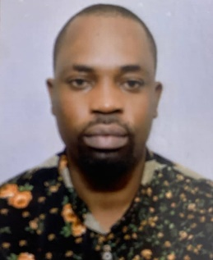

Taofeek Afolabi

+97433262230

+97471915238

ta3640651@gmail.com

Valid Qatar Driver’s License

Qatar

**Objective**

A highly motivated and reliable professional with a Qatar Driver’s License, I have 13 years’ experience in transporting passengers, good safely and efficiently, Skilled in navigating diverse road conditions, maintaining vehicle cleanliness, and delivering excellent customer service, strong knowledge of traffic laws, safety protocols and the ability to handle unexpected situations on the road, committed to ensuring the comfort and safety of passengers while maintaining punctuality and professionalism.

**Work Experience**

Company Driver

King Solomon Motors

Rwanda, March 2018 –April 2024

* Safely transported passengers to their destination in timely and professional manner
* Assisted passengers with luggage and ensured a comfortable ride
* Followed traffic rules and safety regulation to ensure passenger security
* Maintained the cleanliness and functionality of the vehicle

**Education**

Bachelor’s Degree in Civil Engineering

University of Lagos Nigeria

Graduated December 2017

**Skills**

* Safe and defensive driving
* Knowledge of Qatar road regulations and routes
* Vehicle maintenance and troubleshooting
* Excellent communication interpersonal skills
* Punctual and professional behavior
* Customer service and problem solving

**Language**

English (Fluent)

French