Zeeshan Qadir 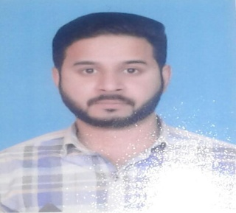

I am a person of high interpersonal relations, approachable, enthusiastic and excellent team player.

House 14 Parss Street 45 Gharhi Shahu Lahore,Pakistan.

Contact:+97450200132, 00923324170175

qadirzeeshan44@gmail.com

Nationality: Pakistan

Currently reside Qatar

Date of birth November 14, 1988

PROFESSIONAL EXPERIENCE

Area Sales Manager Red Bull (Lahore Pakistan) 2009-2014

Heavy vehicle driver Al Fahad Company Saudi Arabia 2015 -2018

Heavy Vehicle Driver Boom construction company Qatar 2018 till to date

EDUCATION

Matriculation. 2005

Hobbies: Cricket & Music

