**Zeeshan Qadir** 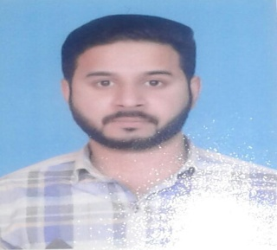

I am a person of high interpersonal relations, approachable, enthusiastic and excellent team player.

House 14 Parss Street 45 Gharhi Shahu Lahore,Pakistan.

Contact:+97450200132, 00923324170175

[qadirzeeshan44@gmail.com](mailto:qadirzeeshan44@gmail.com)

Nationality: Pakistan

Currently reside Qatar

Date of birth November 14, 1988

**PROFESSIONAL EXPERIENCE**

*Area Sales Manager Red Bull (Lahore Pakistan) 2009-2014*

*Heavy vehicle driver Al Fahad Company Saudi Arabia 2015 -2018*

*Heavy Vehicle Driver Boom construction company Qatar 2018 till to date*

**EDUCATION**

Matriculation. 2005

Hobbies: Cricket & Music