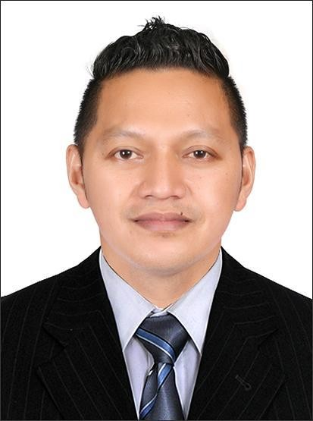Micheal J. Villa

## Doha, Qatar

Ema[il: micheal.villa83@gmail.com](mailto:mariejoyvilla25@gmail.com) Mobile: +974-74059049

## Driving License No. 28360826614

Validity: 2029-04-02

## OBJECTIVES

To contribute to the company’s success by producing the most accurate and feasible illustrations for the tasks assigned to me. I am eager to learn and further my proficiencies by constantly improving my work and accepting all kinds of assignments handed out to me. With this said, I am confident that I can measure up to the expectations of the company.

## KEY STRENGTH

Service and detail oriented

Courteous, well mannered, responsible, self-driven, motivated and can work under pressure with minimum supervision.

Aware of knowledge related in technologies and social media industries.

Experienced in customer relation, excellent organizational skills and time management. Customer Service

PROFESSIONAL WORK EXPERIENCES

# Carpenter Foreman November 2024-Present

# New Aman For Trade, Cleaning Services

# Doha , Qatar

# Carpenter Foreman August 2022 -August 2024

**Creative Closet**

## Doha, Qatar

* Schedule and oversee all aspects of the carpentry work on assigned projects, including materials, equipment, and workers
* Mark cutting lines on materials using a ruler, pencil, chalk, and marking gauge
* Shape or cut materials to specified measurements with hand and power tools
* Assemble and fasten materials to make framework or props using nails, screws, staples, or adhesives
* Install structures or fixtures of wardrobe
* Finish surfaces of woodwork or wallboard using paint, hand tools, or power tools
* Fit and install prefabricated wardrobes and trim
* Inspect completed installations and conduct repairs as necessary
* Maintain a clean and safe work site
* Order and purchase supplies and materials as needed
* Supervise and train other carpenters or helpers as needed

# Finishing Carpenter Wardrobe Installer/Fixer June 2017 up to August 2022 Creative Closet

## Doha, Qatar

* Prepare wood structures for finishing by shaping and trimming with hand or power tools
* Take measurements to develop suitable layout for a fixture
* Assemble wooden components to fabricate useful structures such as desks, and shelves
* Carry out cost and quantity estimates of raw materials required for a finishing project
* Select choice materials needed for the tweaking of wooden fixtures
* Design, build, and install cabinets for new and refurbished homes/offices
* Carry out measurement and installation of wooden floorings
* Provide varnishing and staining service for woodwork
* Guide and direct the activities of interns and trainee finish carpenters
* Implement safety and health regulations during work operations to ensure environmentally friendly and safe structure
* Level and shim door frames during a door hanging process
* Create detailed structures for a film set
* Assist with urgent repairs on midcourse vessels/ships
* Repair and improve the appearance of stringed instruments such as violins, and acoustic guitars
* Install and repair trim on windows, baseboards, and mantels.

# Assistant Carpenter/Fixer February 2015 to June 2017 Climax Point Partition and Décor Factory

## Riyadh, Saudi Arabia

* Take instructions from carpenters to determine the day’s work, and obtain plans and blueprints for each project.
* Study blueprints to assess required tools, equipment, and supplies, and make arrangements to have them procured.
* Set up and calibrate carpentry equipment at the beginning of the shift, ensuring that it is working correctly.
* Acquire supplies such as wood, glue, and nails, after making sure that they are the right types and sizes.
* Follow instructions to saw or cut wood pieces according to provided instructions for each project.
* Set aside cut or chopped wood for use in projects, and follow instructions to apply glue mixtures.
* Assist carpenters in putting wood planks together by holding them in position, and nailing and gluing them properly.
* Hammer in nails and fit screws according to provided instructions, and ensure that any loose nails or broken ones are replaced immediately.
* Assist in placing woodwork in required places so that it can be installed properly.
* Gather all supplies and tools at the end of the day, and ensure that they are put away in a safe and accessible place.
* Oversee inventory of supplies and tools, and communicate low stock situations to the carpenter.

# Pipe Fitter March 2009 to March 2013

**Hanjin Heavy Industries & Construction Co. Ltd.**

## Subic, Zambales, Philippines

* + Applying knowledge of system operation to select the most suitable pipe type and size
  + According to specifications, install support equipment like hangers, brackets, pneumatic equipment, and hydraulic cylinders
  + Inspect the worksite to ensure no obstructions to the pipe and if there are any holes or interference, repair or modify the design.
  + Cutting pipes using handheld and power tools like hammer and chisel, cutting torch, pipe cutter, and pipe cutting machine
  + Threading and bending pipes using pipe bending tools and threading machines
  + Assembling and installing tubes, fittings, and non-metallic attachments.
  + Joining pipes using threads, soldering, brazing, or cemented connections
  + Inspecting piping systems and machinery to detect machinery malfunctions
  + Creating protective pipe layers using paints and other mechanisms
  + Operating material movement machinery to lift pipes, support equipment, and heavy machinery

**Sales Executive February 2005 to December 2007**

# Global Flex Corporation

## Iligan City, Philippines

* Building and sustaining long-lasting relationships with new and existing customers based within an assigned sales territory.
* Traveling within an assigned sales territory to conduct face-to-face meetings with existing and potential customers.
* Continually meeting or exceeding sales targets by selling company products to new and existing customers.
* Developing and implementing an effective sales strategy to drive sales.
* Maintaining an accurate record of all leads, customer accounts, and sales.
* Collaborating with the marketing department to expand brand presence through the creation of suitable marketing materials.
* Researching competitors' products and pricing as well as market conditions.

EDUCATION

* + **UAQ Safety Training Centre and Philippine International Institute Qatar Doha, Qatar**

**Course: AUTOCAD Basic and Advance**

* + **TESDA (Technical Education and Skills Development Authority) Iligan City, Philippines**

**Course: PIPE FITTER**

**October 2014- December 2014**

* + **College Level**

**Lyceum of Iligan Foundation, Inc. Iligan City, Philippines**

**Course: BSMT (BACHELOR OF SCIENCE IN MARITIME TRANSPORTATION) (2003-2004) – (2013-2014)**

* + **High School Diploma**

**Iligan City National High School June 2001-March 2002**

# Qatar Driving License: 28360826614 First Issue: 2024-04-02

**Validity: 2029-04-02**

**PERSONAL INFORMATION**

Nickname : Micheal

Birthdate : February 11, 1983 Citizenship : Filipino

Height : 5’6”

Weight : 73 kg

Religion : Roman Catholic

Civil Status: Married

QID Expiry: June 20, 2025