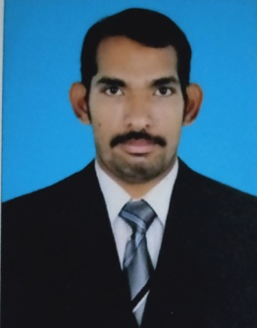

CURRICULUM VITAE

**NAMATH JAAFAR**

Contact No : **+91**-**70382254**

Email : jaafern@gmail.com

**Career Objective**

Over all **15+ years** of Experience in India and Qatar **.**Now seeking to take a challenging, creative role to work on projects and implement the expertise and experience gained and develop quality compounds useful for the organization.

**Education**

**ITI (Diploma) In Electronics From Kannur , Kerala, India**

**Pre Degree From Calicut University ,Kerala, India**

**SSLC from RKHSS , Kannur, Kerala, India**

**Driving License**

**Qatar License No: 28235614543( Light and Heavy)**

**India License No: 58/6815/2009**

**Languages**

**English : Fluent**

**Arabic : Working knowledge**

**Hindi : Fluent**

**Malayalam : Fluent**

**Skills**

* **Messenger**
* **Light Driver**
* **Heavy Driver**

**Personal skills**

**Friendly, Efficient, Humorous, Mature, Loyal and Organized**

**Motivated, Competitive, Ambitious and Self-confident**

**Experience & Activities**

* **Worked as Salesman in Hot N Cool Restaurant, Doha, Qatar for a Period of 4 years**
* **Worked as a Bus Driver Cum Messenger in AL-MUFTHAH Rent A CAR, Doha, Qatar**
* **Worked as a Driver in Netsec Solution, Calicut, Kerala India for a Period of 3 years**

**Personal Details:**

**___________________________________**

**Name : NAMATH JAAFAR**

**Permanent address : NAMATH House , PO OLAVILAM**

**Nationality : INDIAN**

**Gender : MALE**

**Date of birth : 28/01/1982**

**Marital status : MARRIED**

**Mobile : +974-70382254**

**DECLARATION:**

**--------------------------------------------------------------**

**I hereby declare that all the information and facts stated herein and above are correct to the best of My knowledge.**

**Date: JAAFAR NAMATH**

**Place : Kerala .Indian**