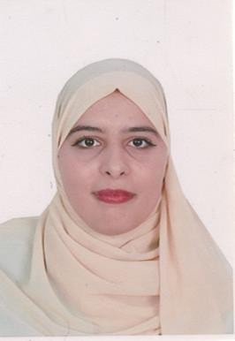 | Bahlouli leila  Agronomy engineer
CONTACT    Address  Doha    Phone number    Email  joulyabahlouli@gmail.comm  SKILLS  - Computer skills  - Business development  - Commercial negotiating  - Key account management  - Leadership and team management  - Customer service  - Market analysis  - Used critical thinking and research skills to develop a curriculum using materials from a variety of academic resources  - Developed multimedia presentations using videos, slideshows and other technology  - Graded term papers and other assignments with strong attention to detail  LANGUAGES  French  English (Level B2)  Arabic Aaara  HOBBIES  - Soccer  - Car race  - Camping | PROFILE  I am dynamic and serious about promoting sustainable agriculture, eager to put into practice the skills acquired at the National Higher School of Agronomy of Mostaganem, particularly in soil management, protection and development of land, also fertilization. and soil conservation. Strong significant experience in the agronomic field, marketing, sales, continuing education, I am determined to actively contribute to the innovation and efficiency of agricultural practices  Working as a professor of natural and life sciences is among the most important jobs that I aspire to in order to convey all information and provide experiences and expertise to students.  Excellent interpersonal and communication skills  Expertise in the area of ​​study that you are applying for the lecturership  Exceptional verbal and written skills  Organizational skills as well as demonstrating a cooperative and professional interest towards working with a faculty, staff and students  Interest in curating and designing course curriculums  Project management and planning skills  Interested in mentoring undergraduates  Ability to facilitate an interactive learning environment with an integral focus on research and practical training as well.  PROFESSIONAL EXPERIENCE  Education 2fevrier _15mai 2024  - Primary school teacher  Agronomy engineer 12juin _15january  - Saleswoman in a store selling agricultural medicines and agricultural equipment  - Agricultural follow-up  - Treatment of fungal diseases and insects  EDUCATION  Agricultural Engineer with a degree in Agricultural Engineer + Master 2 in Agricultural Sciences in hight School agronomie mostaganem

