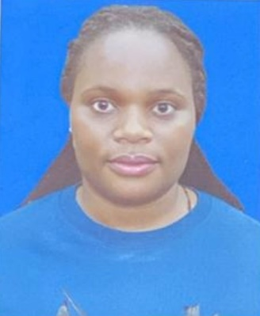 |  | NAKANYIKE BRIDGET SARAH  DRIVER
Profile  I am a highly organized dedicated and well oriented with abilities to improve working environment commitment to follow employees and sensitive to organization’s concern. I posses’ strong interpersonal skills, demonstrating utmost description and integrity when dealing with confidential information. I am competent enough to handle my duties.  Contact  PHONE:  +97451121813  EMAIL:  sankanyike@gmai.com  SKILLS  Computer  Public relations.  Critical thinking.  Effective communication.  leadership.  Coordinating and management.  Inter personal skills |  | EDUCATION  CRANE HIGH SCHOOL  2007-2008  UGANDA ADVANCED CERTIFICATE OF EDUCATION  NKUMBA SECONDARY SCHOOL  2003-2006  UGANDA CERTIFICATE OF EDUCATION  WORK EXPERIENCE  Al ZAHARA MAN POWER [ OFFICE MESSENGER AND DRIVER]  2024-2025  - In charge of all flight arrangements for all the staff and make sure they are dropped and picked on time.  - Make sure that all staff are dropped and picked on time to all locations.  - Do administrative tasks like picking invoices from clients and filling them.  QATAR FAMILY [DRIVER]  2022-2023  - Make sure that all children are dropped and picked from school.  - Drive all family members to supermarkets, hospitals and family visits.  - Buy all groceries that the family needs and make sure the receipts are kept.  - In charge of car is repaired and well maintained all the time  POSTA UGANDA [ OFFICE MESSENGER]  2020-2022  - Receiving all incoming calls from the switch board and make sure they are forwarded to the right people.  - Make sure all received parcels are send to respective destination.  - Do all administrative tasks assign to me by my boss.  - Make sure that the office is kept clean and all stationary needed is available on time.  - Maintain office equipment and make sure they are serviced and repaired on time.  - Manage all meetings and make sure all minutes are recorded and filled.  - Maintain basic housekeeping duties like keeping the office clean.  REFEREES:  - Zziwa Isaac  Cluster Security Manager  Ibis and Adagio Aparthotels  ziwa.isaac@accor.com  Mob: +97450339848  - Mr. Abdul-Kayum Makubuya  Al Jameel Medical Services  Facility Safety Manager  abdulkayummakubuya@gmail.com  Mob: +97470210169  - Ms. Jowaharah Salem  Accountant  Al Zahara Manpower  Mob: +97466500548  I understand that the underlined information provided above describe my true identity, character, qualifications and experience.  Name: Nakanyike Bridget Sarah  Date: 16/04/2025  mmmmkkkkkkkRREmmCRUGJG

