M.M.Mohamed Jibry

765/105 A, Bodhirajarama MW

Maligawatte

Colombo 10.

Tel: 0777895724, 0757895724

**Qatar: +974 70479866**

Email: malikjibry@gmail.com

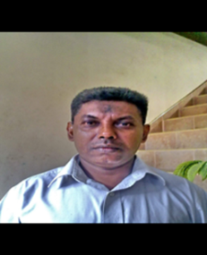

**Any Suitable Post**

**Camp boss- Cashier- Stock maintain-import coordinate- office assistant-Receptionist**

Name in Full : Malik Mudaliyan Mohamed Jibry

Date of Birth : 12th February 1962

Gender : Male

Civil Status : Married

Nationality : Sri Lankan

NIC NO : 620431010V

Experience : Two years working in M.I.M. Muneer Dye Works Ltd. As a Sale’s Rep, Invoicing Stock/Ledger maintaining.

2 Years Working Safeway Super Market in KSA as a Cashier

19 years in M.C.Abdul Rahim & Bros (pvt) Ltd. Import coordinator Cashier and office work etc.

Cashier: Cash handling cash, down payment and cash cheques receipt and billing daily control of cash and cheques coordinate and follow up with Finance Department petty cash and other payment

IMPORTS: Apply L/C, TT, DA, DP sending P/O dealing with Bank & Supplier. Check if received original documents are complete and forward to logistic department for clearance of the Goods & costing

Additional Works: Utility Bill Payments, Insurance Apply/Claim of Marine Vehicle and Properties. News paper Advertising, stationery printing and office maintain.

2 Years working **2012 to 2013** in Tamimi Global Co; Ltd. Jubail KSA as a camp admin

3 years working**19.08.2014 to 15.11,2017** in Qatar Speed House as a Camp-in-charge

2.5 years working **2019 to 2022** in **Asian Hardware Pte Ltd** as a Receptionist

**Present working in Smart House Qatar from 2022 as a Camp boss**

Non Related Referees: M. R. M Razmy Director RM Trading 0773542286

Mohamed Ifzal Director Everlight Chemical 0777763392

Thanking you,

Yours faithfully,