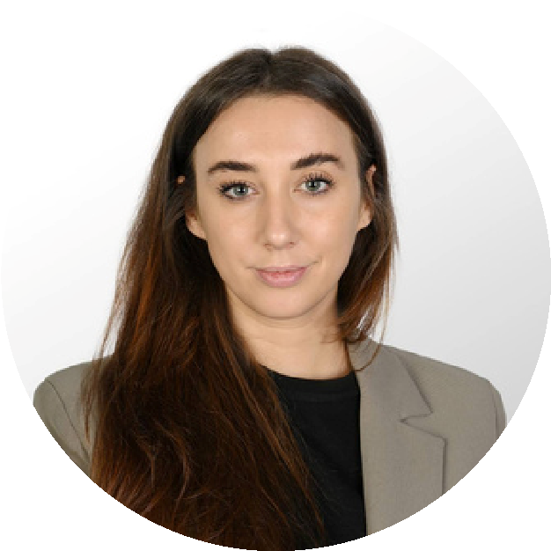

**Sales & Solutions Specialist**

***ICF Certified Coach***

***Customer Success & Engagement Strategist***

**JULIA (AL-SAUDI) STADNIK**

**SKILLS**

**TECHNICAL SKILLS**

MA in Marketing

BA in Marketing

Kharkiv Institute of Business and

Management

Kharkiv Institute of Business and

Management

2013

2012

**EDUCATION**

Procurement & Vendor Management

Contract Management

HR Administration & People Operations

Str

ategic Sourcing & Cost Optimization

Recruitment & Talent Acquisition

Empl

oyee Engagement & Training

Programs

Organizational Psychology & Leadership

Development

Data Analysis & Reporting

Stakeholder Management & Cross-

functional Collaboration

Com

pliance & Process Improvement

WallPost ERP & CRM Systems

Microsoft

Office

Suite

Excel,

(

Word,

PowerPoint, SharePoint, Teams)

Canva (Corporate Presentations & Training

Materials)

Managed 150+ key accounts, driving a 20% increase in repeat business through

exceptional relationship management.

Led contract negotiations, achieving an average 10% annual sales growth

h.

Organized

promotional

events

and

business

development

initiatives,

increasing

brand visibility by 25%.

*Sales & Customer Relationship Manager*

**Global**

**-**

**Medica**

, Kharkiv, Ukraine | Sept 2013 – Aug 2017

Dynamic and client-focused IT Sales & Solutions Specialist with a proven track record in

driving sales of medical and digital technology solutions across public and private sectors.

Skilled in delivering tailored product demonstrations, configuring client-centric solutions, and

managing

full

sales

cycles

from

lead

qualification

to

post-sale

support.

Adept

at

coordinating with international vendors, technical teams, and procurement stakeholders to

deliver

scalable,

value-driven

offerings.

Known

for

building

lasting

client

relationships,

contributing to tenders in healthcare, government, and corporate sectors.

**ABOUT ME**

**WORK EXPERIENCE**

*Sales & Solutions Specialist*

**Health Innovations**

, Doha, Qatar | Nov 2021 - Present

Delivers

tailored

product

demonstrations

and

solution

presentations

to

both

public

and

private

sector

clients,

enhancing

understanding

of

digital

healthcare solutions and increasing conversion rates.

Generated 480+ detailed sales quotations and configured medical technology

solutions based on client needs and site-specific requirements.

Contribut

ed to acquiring 4 high-value government and hospital tenders (worth

over $1M) by aligning technical offerings with client specifications.

Maintained and grew a portfolio of 120+ Qatari clients, providing consultative

sales support and boosting customer retention by 15%.

Leverages

CRM

and

ERP

tools

to

manage

sales

pipelines,

track

client

communication, and forecast sales performance across solution categories.

Conducts onsite assessments and coordina

tes the configuration of IT-enabled

medical devices, ensuring full compatibility with hospital infrastructure.

*Sales & Procurement Coordinator*

**National Construction Group**

, Kharkiv, Ukraine | Aug 2017 – Oct 2019

*People & Vendor Operations Specialist*

**Lamar**

**Group**

, Doha, Qatar | Nov 2019 – Nov 2021

Managed HR records and CRM systems with 100% data accuracy, enhancing

internal reporting and workflow automation.

Provided high-level administrative support, reduc

ing operational inefficiencies

by 20%.

Facilitated seamless employee onboarding and enhanced guest experiences,

contributing to a 10% increase in client satisfaction.

Processed 200+ sales agreements, ensuring financial compliance and reducing

overdue payments.

Participated

in

procurement

planning

and

vendor

negotiations,

improving

purchasing efficiency and reducing costs.

Enhanced internal documentation and compliance workflows, increasing team

productivity.

Doha, Qatar

stadnikiuliia@gmail.com

+974 3110 8804

ICF Certified Coach

International Coaching Federation