CURRICULUM VITAE

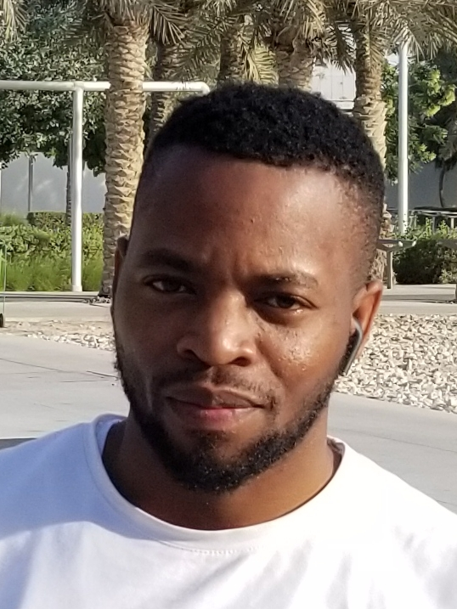
BIO DATA
Names: MUZAFARU KIMERA
Position: DRIVER SUPERVISOR
Nationality: UGANDAN
E-mail: kimeratechno@gmail.com
Tel: 50425409
Location: DOHA, QATAR

PERSONAL PROFILE
I am a dedicated, focused, punctual and extremely enthusiastic driver with a passion for service delivery. I possess excellent communication and listening skills that allows me to interact with clients physically and over other electronic mediums of communication effectively. My skills are born out of personality, studying and previous work experience which involved a number of jobs, training and responsibilities. As a polite enthusiastic, self-motivated individual, combined with my experience I believe that I would make a great asset to your team.

CAREER OVER VIEW:
To demonstrate to both myself and my team gained skills and abilities under limited supervision and ethical execution of duties and responsibilities to effectively meet organizational goal with moderate attitude for initiative and independent judgment.
To obtain a greater experience of customer services that will allow me use existing resources at my disposal and those already acquired to offer better customer services.

KEY STRENGTH
- Can drive both automatic and manual transmission cars
- Ten (10) year experience as a driver and supervisor
- Good team player and motivator
- Time conscious and punctual
- Loyal
- Self-motivated with a high attention to detail

WORK HISTORY
May 2017 – Oct 2019, TAXI DRIVER KARWA, MOWASALAT DOHA, QATAR
Duties:
- Picking up and delivering customers.
- Taking the fastest and safest route for customers
- Helping to load and unload the vehicle for customers
- Calculating the right fare and returning the correct change to customers
- Keeping the vehicle clean and in good working conditions always

Sept 2019 – Oct 2022, VALET DRIVING SUPERVISOR, MR. VALET DOHA, QATAR
Duties:
- Greeting and warmly welcoming guests of the establishment
- Ensuring my team’s readiness for work daily from time management to task execution
- Parking and supervising the parking of cars safely
- Retrieving cars for guests in a timely manner
- Ensuring that parked cars are locked and that keys are stored safely or returned to the owner
- Assisting with unloading guests’ luggage

ACADEMIC BACKGROUND
- UGANDA CERTIFICATE OF EDUCATION – 2009
- UGANDA ADVANCED CERTIFICATE OF EDUCATION – 2011

DECLARATION
I MUZAFARU KIMERA, declare that the information given herein is true to the best of my knowledge.

Muzafaru Kimera

