**CURRICULUM VITAE (CV)**

**Personal Information:**

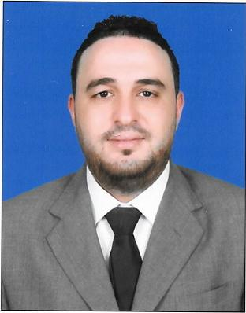

**Name:** LAHMEDI WISSEM

**Date of Birth:** 16/10/1992

**Nationality:** Tunisian

**Address :** Doha / Qatar

**Phone number:**  33942842

**Email:** [Lahmediwissem.1@gmail.com](mailto:Lahmediwissem.1@gmail.com)

**Family Status:** Single

**Valid Working QID with NOC**

**Qatari Driving license *.***

**Objective:**

-Achieve my goals Step by step

-Access to my professional dream through sacrifice and effort at work and win the love

Of all colleagues and customer

-To obtain a position at a reputable company where I can maximize my

management skills ,quality assurance and program development.

I am eager to learn , I enjoy overcoming challenges, and I am a responsible,

intelligent and experienced retail professional with an extensive background in

both retail and sales in large boutiques.

**Key Skills:**

**-Communication –** Deals with internal and external customers at all levels via

Telephone and email, to ensure successful communication via actively listening

And probing questions.

-**Problem Solving** -Approach the problem with external and internal business

Partners to find the appropriate solutions.

-**Team player –** Enjoys sharing knowledge and encouraging development of

Others to achieve specific team goals.

-**Planning and organizing -**Refined planning and organizational skills that

Balance work, team support and assign responsibilities in a timely and professional

Manner.

**-Systems knowledge-** Microsoft Office, Excel , Outlook and internet.

-**Good experience in Sales and Marketing**

-The account on the Cashier machine is very perfect

- Experience in selling products and convincing the customer to buy them

- Experience in arranging , accounting and organizing the Items in ware house and Shops .

-All conditions of group or individual work at what Time .

-Dealing professionally with different people and implementing and carrying out immediately all their requests and wishes .

**Professional Experience:**

**Position:**

**- GENERAL MANAGER : MELLISIA ABAYA SHOP . FESTIVAL CITY 2023/2024**

**-Beauty advisor: Watson’s Showroom Festival city mall 2022. Al Futtaim group**

**-Sales Representative : Salesman in Al Muftah.group center 2019..2021** electronics house products and Home appliances

**-*Sales Assistant in Toys R Us Al SAAD : In Al Futtaim group***

***January 2018 - Mars 2019***

**-Music Teatcher** **In private School 2015 -2016**

**-Supervisor:** in "**GRAÊT Company**" for electronic house products **2011- 2012**

**-Sales Representative and Promoter** in a Branch Unilever Company

Monastir 2010 -2011 “ **UNILEVER** “ Branch Tunisia ( COCA COLA , OMO,KNOR

SINSILK, KAJOLINE ….)

**Languages :**

**-Arabic :** Mother language

**-English :** Very good reading , writing and speaking.

**-French :** Very good reading , writing and speaking.

**Education:**

**-High School Baccalaureate degree** - Economics ( Graduated in 2011).

-**Degree in Computer Sience**

**-Degree in Arabic Musique :** University Degree majoring in Arabic Music **Piano**

-**General English Certificate (Diploma)**in Institute **KSAR HLEL language** Graduated in 2014 / Course for 1 Years

- **Customs formalities Technicians in private university** INFO 2000 Tunisia With Experience .

**References are available upon request**