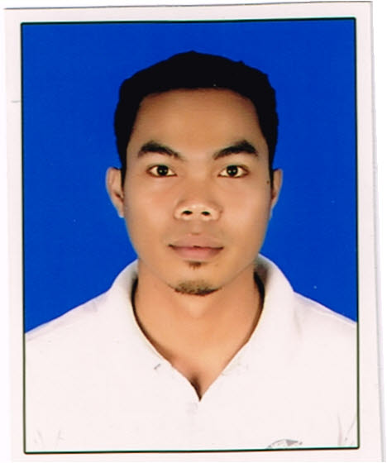 |  |  | christian a. duritan  christian.duritan@yahoo.com  cduritan@gmail.com  +974 30135037
Objective |  |  | Experience
Highly skilled with over 10years experience in driving light to heavy vehicle abroad. Seeking a driver position at reputable company and aiming to utilized my skills and commitment to excellent customer service to ensure safety and client satisfaction. |  |  | TRANSPORT DRIVER●JOLLIBEE FOOD CORP(QATAR)●AUGUST 2021 TO PRESENT  Perform vehicle safety inspection, plan and follow best route to ensure the goods and passengers are timely and safely transported to their designated locations. Ensure that all necessary paperwork and documentation are in order before transporting goods and passengers. Comply with all traffic laws and company safety regulations.  truck driver • gulf warehousing company(Ikea) • march 2017- september 2020  Pre- inspect truck, pick up goods and materials, verify loads accuracy and deliver them as instructed.  team leader assembler • tawseel trading co.(flow) ghassan ahmed al sulaiman furnishing trading co.ltd saudi arabia • march 2014 – july 2016  Delegating task to optimize team performance, organize the work environment to improve productivity. Setting deadlines, over seeing and managing day to day team operations.  driver cum assembler• gulf warehousing company(Ikea) october 2012 – november 2013  Prepares work to be accomplished by studying parts lists and gathering parts, subassemblies, tools and materials. Reads and deciphers schematics, blueprints and assembly instructions and conducts quality control checks.
Skills |  |  | Education
Excellent driving skills from light to heavy vehicle.  Proficient in computer programs such as Microsoft office and the like. |  |  | electronic technology • 2008 • technical education skills and development authority(TESDA)  NC II Consumer Electronics Servicing-trained in repairing electronics gadgets and appliances such as mobile phones, televisions, radios and other similar products.  security system • 2016 • COMSOFIL DAMMAM saudi arabia  Closed Circuit Television Installation- trained to installed, troubleshoot and repair various CCTV system.

