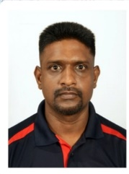**CURRICULUM VITAE**

**H A Chaminda**

**Personal Information**

* **Full Name:**  Hetti Arachchilage Chaminda
* **Address:**  No. 200/1, Augusta Watta, Udaperadeniya, Peradeniya
* **Contact No:** +94 773742011 / +960 9899461
* **Email:**  <chamindakandy@gmail.com>
* **Date of Birth:** 29th June 1981
* **Age:** 43 years
* **Gender:** Male
* **Nationality:**  Sri Lankan
* **Passport No:**  N104985851

**Professional Summary**

A highly skilled and passionate technician with over 12 years of experience in power tools, garden tools, small engine machines, and small generators. Adept at troubleshooting, repairs, and maintenance, with a strong background in team coordination and leadership. Committed to delivering high-quality technical solutions and ensuring operational efficiency.

* **Power Tools Expertise:** grinders, drills, miter saws, rotary hammers, demolition hammers, electric breakers, cut-offs, chop saws, coring machines, sanders, circular saws, planers, lawn mowers, routers,
* jig-saws, and high-pressure washers (both corded and cordless).
* **Engine Tools Expertise:** Brush cutters, chain saws, leaf blowers, sprayers, lawn mowers, gasoline generators (up to 6kW), diesel generators (up to 5kW).
* **Pneumatic Tools Expertise:** Nailers, staplers, air compressors and more.

**Work Experience**

**Technician | State Trading Organization, Maldives**

**July 2023 – Present**

* Servicing and repairing power tools and small engine tools.
* Conducting product testing and spare parts forecasting.
* Ensuring high-quality maintenance to meet industry standards.

**Senior Technician | Brown & Company PLC, Sri Lanka**

**2016 – 2023**

* Led and trained technicians at the Browns Power Tools Repair Center.
* Managed estimations, repairs, and maintenance of power tools, generators, and compressors.
* Conducted product testing, spare parts forecasting, and service team coordination.
* Provided demonstrations and safety training for tool users.
* Attended specialized training programs by Makita Singapore on cordless tools, engine tools, and breakers.

**Power Tools Technician | Nehmeh Maintenance & Services, Qatar**

**2013 – 2016**

* Repaired and maintained a wide range of tools and machinery.
* Conducted product testing and forecasted spare part requirements.
* Participated in specialized training on Makita cordless and pneumatic tools.

**Educational Qualifications**

* **G.C.E. Ordinary Level Examination (1997):** Four credits & three simple passes.
* **Completed Electronics Course** at ACE Electronic School, Kandy.

**Technical Skills & Certifications**

* Proficiency in repairing power tools, garden tools, small engine machines, and generators.
* Strong knowledge of electronic repairs for household and kitchen appliances.
* Expertise in Arduino, Micro Python, and Microchip Studio for electronic projects.
* Hands-on experience with product testing and spare parts forecasting.
* Effective communication skills in English and Sinhala (spoken and written).

**Additional Training & Certifications**

* Specialized training in Makita cordless and pneumatic tools.
* Training in Makita Singapore on engine tools and breakers.
* Safety training and demonstration experience for power tool users.

**Declaration**

I hereby certify that the information provided above is true and correct to the best of my knowledge.

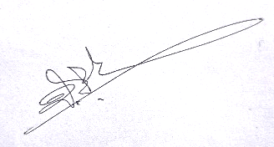

--------------------

H A Chaminda