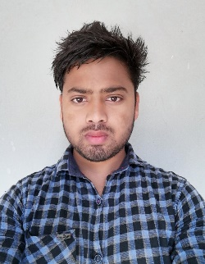**Rabin Kumar Ray**

Street-973, Zone-14, Doha, Qatar

Email: rabinkumarray476@gmail.com | Mobile: +974 7066 5671

**Personal Details**

Date of Birth: 26 August 1994

Nationality: Nepalese

Gender: Male

Visa Status: (NOC Available)

Driving License: Qatar Light Vehicle (Manual)

**Objective**

Dedicated and detail-oriented professional with experience in data entry, document control, inventory management, and driving. Skilled in maintaining records, managing submittal logs, ensuring compliance, and safely transporting staff and materials. Seeking a position to apply my organizational, technical, and driving skills to contribute effectively to team success.

**Work Experience**

**Driver**

Arabian map – LUSAIL. Al RAWDA academy Doha, Qatar. January 2024 – Present

* Responsible for pick-up and drop-off of workers to and from construction sites.
* Ensured timely transportation and followed all road safety and company regulations.
* Maintained cleanliness and routine checks of the vehicle.

**Document Controller**

Sak Trading & Contracting – Al-Gharafa, Qatar. December 2020 – September 2023

* Managed project submittals, maintained accurate logs, and ensured adherence to project documentation standards.
* Coordinated with engineers, consultants, and other stakeholders for document reviews and approvals.

**MEP Storekeeper**

Sak Holding Group – Al-Wakrah, Qatar. March 2018 – August 2019

* Handled inventory of MEP materials, ensuring stock accuracy and timely replenishment.
* Maintained compliance with safety procedures and organized proper storage of materials.

**Timekeeper**

Sak Trading & Contracting – Al-Wakrah, Qatar. August 2015 – September 2017.

* Monitored and recorded employee work hours.
* Coordinated closely with HR and payroll departments to ensure accurate wage processing.

**Education**

Higher Secondary School in Computer Science

All India Council for Open Education – Delhi, India

July 2011 – July 2013

**Skills**

* Driving and site transportation
* Data entry and submittal log management
* Proficient in Microsoft Office Suite (Excel, Word, Outlook)
* Strong organizational and problem-solving skills
* Attention to detail and effective communication

**Languages**

* English
* Nepali
* Hindi
* Arabic (Intermediate)

**Hobbies**

* Playing Volleyball.
* Visiting New places.
* Listening to music.