**CURRICULUM VITAE** 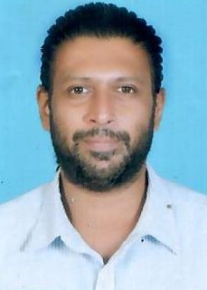

**HEMPEL JAYADEVAN**

Email: [Jayadevanhempel5@gmail.com](mailto:Jayadevanhempel5@gmail.com)

Mob: +974 66053006

Doha, Qatar

**JOB OBJECTIVE: -**

Seeking a suitable career-oriented position with a progressive organization where my academic background will enable me to make a significant contribution and provide me an opportunity for personal growth and advancement.

**PERSONAL INFORMATION: -**

* Name : HEMPEL JAYADEVAN
* Date of Birth : 20/06/1985
* ID Number : 28535600436
* Sex : Male
* Nationality : Indian
* Marital Status : Single

**EDUCATIONAL QUALIFICATIONS:**

10th Passed from M.E.S INDIAN SCHOOL

**WORK EXPERIENCE: -**

* Worked as Messenger cum LV Driver in MACE Group for 2 years (QATAR)
* Worked as Valet Driver for 3 years in Salam Gate (QATAR)
* Worked as Light Vehicle Driver for 3 years in Terrestrial Contracting W.L.L(QATAR)
* Worked as Light Vehicle Driver for 2 years in Architectural Joinery (QATAR)

**LANGUAGES KNOWN**:

* ENGLISH HINDI TAMIL MALAYALAM

**DECLARATION:** I hereby assure you that all the above-mentioned information is true and correct to the best of my knowledge and belief.