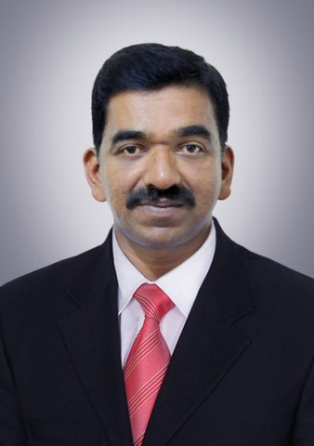

UMMAR MOOSA

ummarweltec@gmail.com +974 3319 3420

OBJECTIVE:
Seeking a challenging career and excellent growth in a reputed organization where I can implement my skills and abilities gained through my education and experience.
WORK EXPERIENCE & PROFESSIONAL SKILLS
M/s. Riondel Trading & Sanitary Fittings W.L.L. Business Executive, Qlymax , Made in Qatar (From January 2020 to till date)
Excellent exposure in the field of sales Plumbing Materials Shower Mixer, Sink Mixer, Basing Mixer and Bidet Sprayers. Brand Qlymax, Made in Qatar.

- Attending B2B Meeting
- Setting up new marketing strategies
- Managing Customer Relationship.
- Making Sales Calls and handling enquiries from potential customers
- Providing product knowledge to clients.
- Product presentations.
- Market analysing.
- Analysing competitor product knowledge and price.
- Preparing quotations.
- Achieving target.

Major Customer:

Waseef, Bricktone Contracting Company, , Ezdan , Millennium Hotel, La Maison Hotel and Major Traders in Qatar Market. Etc.,

M/s. Reliable Motors, Dealer - Mahindra Trucks and Buses
Neelikonampalayam, Coimbatore (from January 15, 2019 to Nov 20, 2019)
Excellent exposure in the field of sales LCV Trucks and Buses to meet set targets.
- Finding customers in the various field of Quarry, Builders, Companies and Schools.
- Find out the customer requirements.
- Preparing quotation as per the customer needs.
- Deliver the product as per customer requirements on time.

M/s. Weltec W.L.L., Industrial Area, Doha, Qatar (from November 2005 to September 2018)
Sales Executive
Excellent exposure in the field of sales - welding electrodes, welding machines, heat treatment units and accessories to meet set targets.
- Setting up new marketing strategies
- Managing Customer Relationship.
- Supporting foreign manufactures for finding prospective customers from local market
- Making Sales Calls and handling enquiries from potential customers
- Providing product knowledge to clients.
- Preparing & monitoring monthly sales chart.
- Product presentations.
- Market analysing.
- Analysing competitor product knowledge and price.
- Preparing quotations.
- Achieving target.

Dealers:

Welding Electrodes:-

- Kiswel, Korea. 2. AtomArc, USA. 3. Sandvik, Sweden. 4. AlcoTec, USA 5. Special Metal, USA

Abrasives:
- Star-flex Cutting & Grinding Disc
- Flexo-vit Cutting and Grinding Discs, Italy.

Welding Cable:
- Tumka, Turkey
Major Customers:
NDSQ, Raslaffan, Nkom Raslaffan, Eversendai Engineering, Debaj, BSI Steels etc

Indian Statistical Institute, Tamil Nadu, India (April 1996 – November 2004)
Accounts Assistant cum Computer Operator
- Preparing Accounts Statement.
- Preparing ISO Project Reports.
- Preparing Presentations for ISO Course.
- Software & Hardware supports.

P.S. Agencies , Coimbatore, India ( August 1991 – September 1996)
Territorial Sales Representative
- Marketing.
- Achieving Target
- Product Merchandising
- Co-ordination with sales team
Education:
B.A. Economics course completed.
COMPUTER KNOWLEDGE
- MS-OFFICE all versions
- Tally software

PERSONAL PROFILE
Date of Birth : 22nd February 1973
Gender : Male
Marital Status : Married with 3 children
Nationality : Indian
Passport No. : J 5373207
Qatar ID : 27335608129
Languages Known : English, Hindi, Tamil and Malayalam
Contact Details:
Mobile : +974 3319 3420

Declaration
I hereby declare that the above details are true to the best of my knowledge.

