Curriculum Vitae
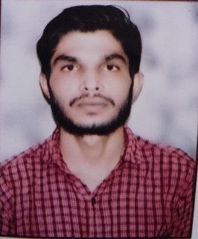

Mohammad Anas
Contact no: +974-71270941
Address: Doha-Qatar
E-mail: mohdasim.0004@gmail.com

CAREER OBJECTIVE:

- To work in a challenging environment where I can experience personal growth, development and to be in a responsible position where I can noticeably contribute to the organization’s growth and success.

ACADEMIC QUALIFICATIONS:

- Intermediate (12th) from U.P. Board, Allahabad (India) in 2019
- High School (10th) from U.P. Board, Allahabad (India) in 2016

COMPUTER AWARENESS:

- Auto Cad,2D, 3D ,3D Max,
- MS Windows, MS Excel
- MS Office suite, Photo Shop
- Revit

PROFESSIONAL QUALIFICATION:

- Diploma in Auto Cad Draughtsman (Civil)
- Diploma in Computer Application

ACHIVEMENT & EXPERIENCE:

- Presently working as a site Foreman cum Draftsman at Asia Alliance Trading and Cont. Real, Qatar from 01-08-2023.
- Six months working experience as a Civil Draughtsman at DBD Construction India from
29-12-2022 to 15-07-2023.

JOB RESPONSIBLITIES:

Producing 2D and 3D drawings, using AutoCAD 2018,20 and 3D max designing.
- Calculate dimensions and material requirements.
- Edit technical draughts based on the recommendations of project engineers and architects.
- Outline the project’s construction process on the technical drawings.
- Preparing shop drawing and as-built drawings for all discipline like Civil and Electrical. drawings preparing presentation drawings for tendering as well as for the project co-ordination for the site.

Managed a team of 15 employees at site Execution, ensuring quality control and safety regulations were met.

Ensuring compliance of work as per drawing, and specifications.

Collecting information from the site and implementing in the as-built drawing.

Handling project drawings with the concern engineering staff, provide functional support to the design Architect / Engineering on the assigned task project.

Performs other duties as directed by management, collaborate with design staff by establishing methods of closer communication and coordination.

STRENGHTS:

- Ability to adjust in any environment & hard working.
- Quick learner, Punctuality, Self Confidence, Good Motivator.

LANGUAGES KNOWN:

- English
- Hindi
- Urdu

INTEREST & ACTIVITIES:

- Travelling
- Playing Cricket

PERSONAL PROFILE & VISA STATUS:

- Date of Birth : 8th August,2000
- Passport Number : V138833
- Gender : Male
- Marital Status : Single
- Nationality : Indian
- Qatari Id : 30035616530
- Expiry Date : 29-07-2025

DECLARATION:

- I hereby declare that all the information furnished above is true and correct to the best of my knowledge and belief.

(Mohammad Anas)

