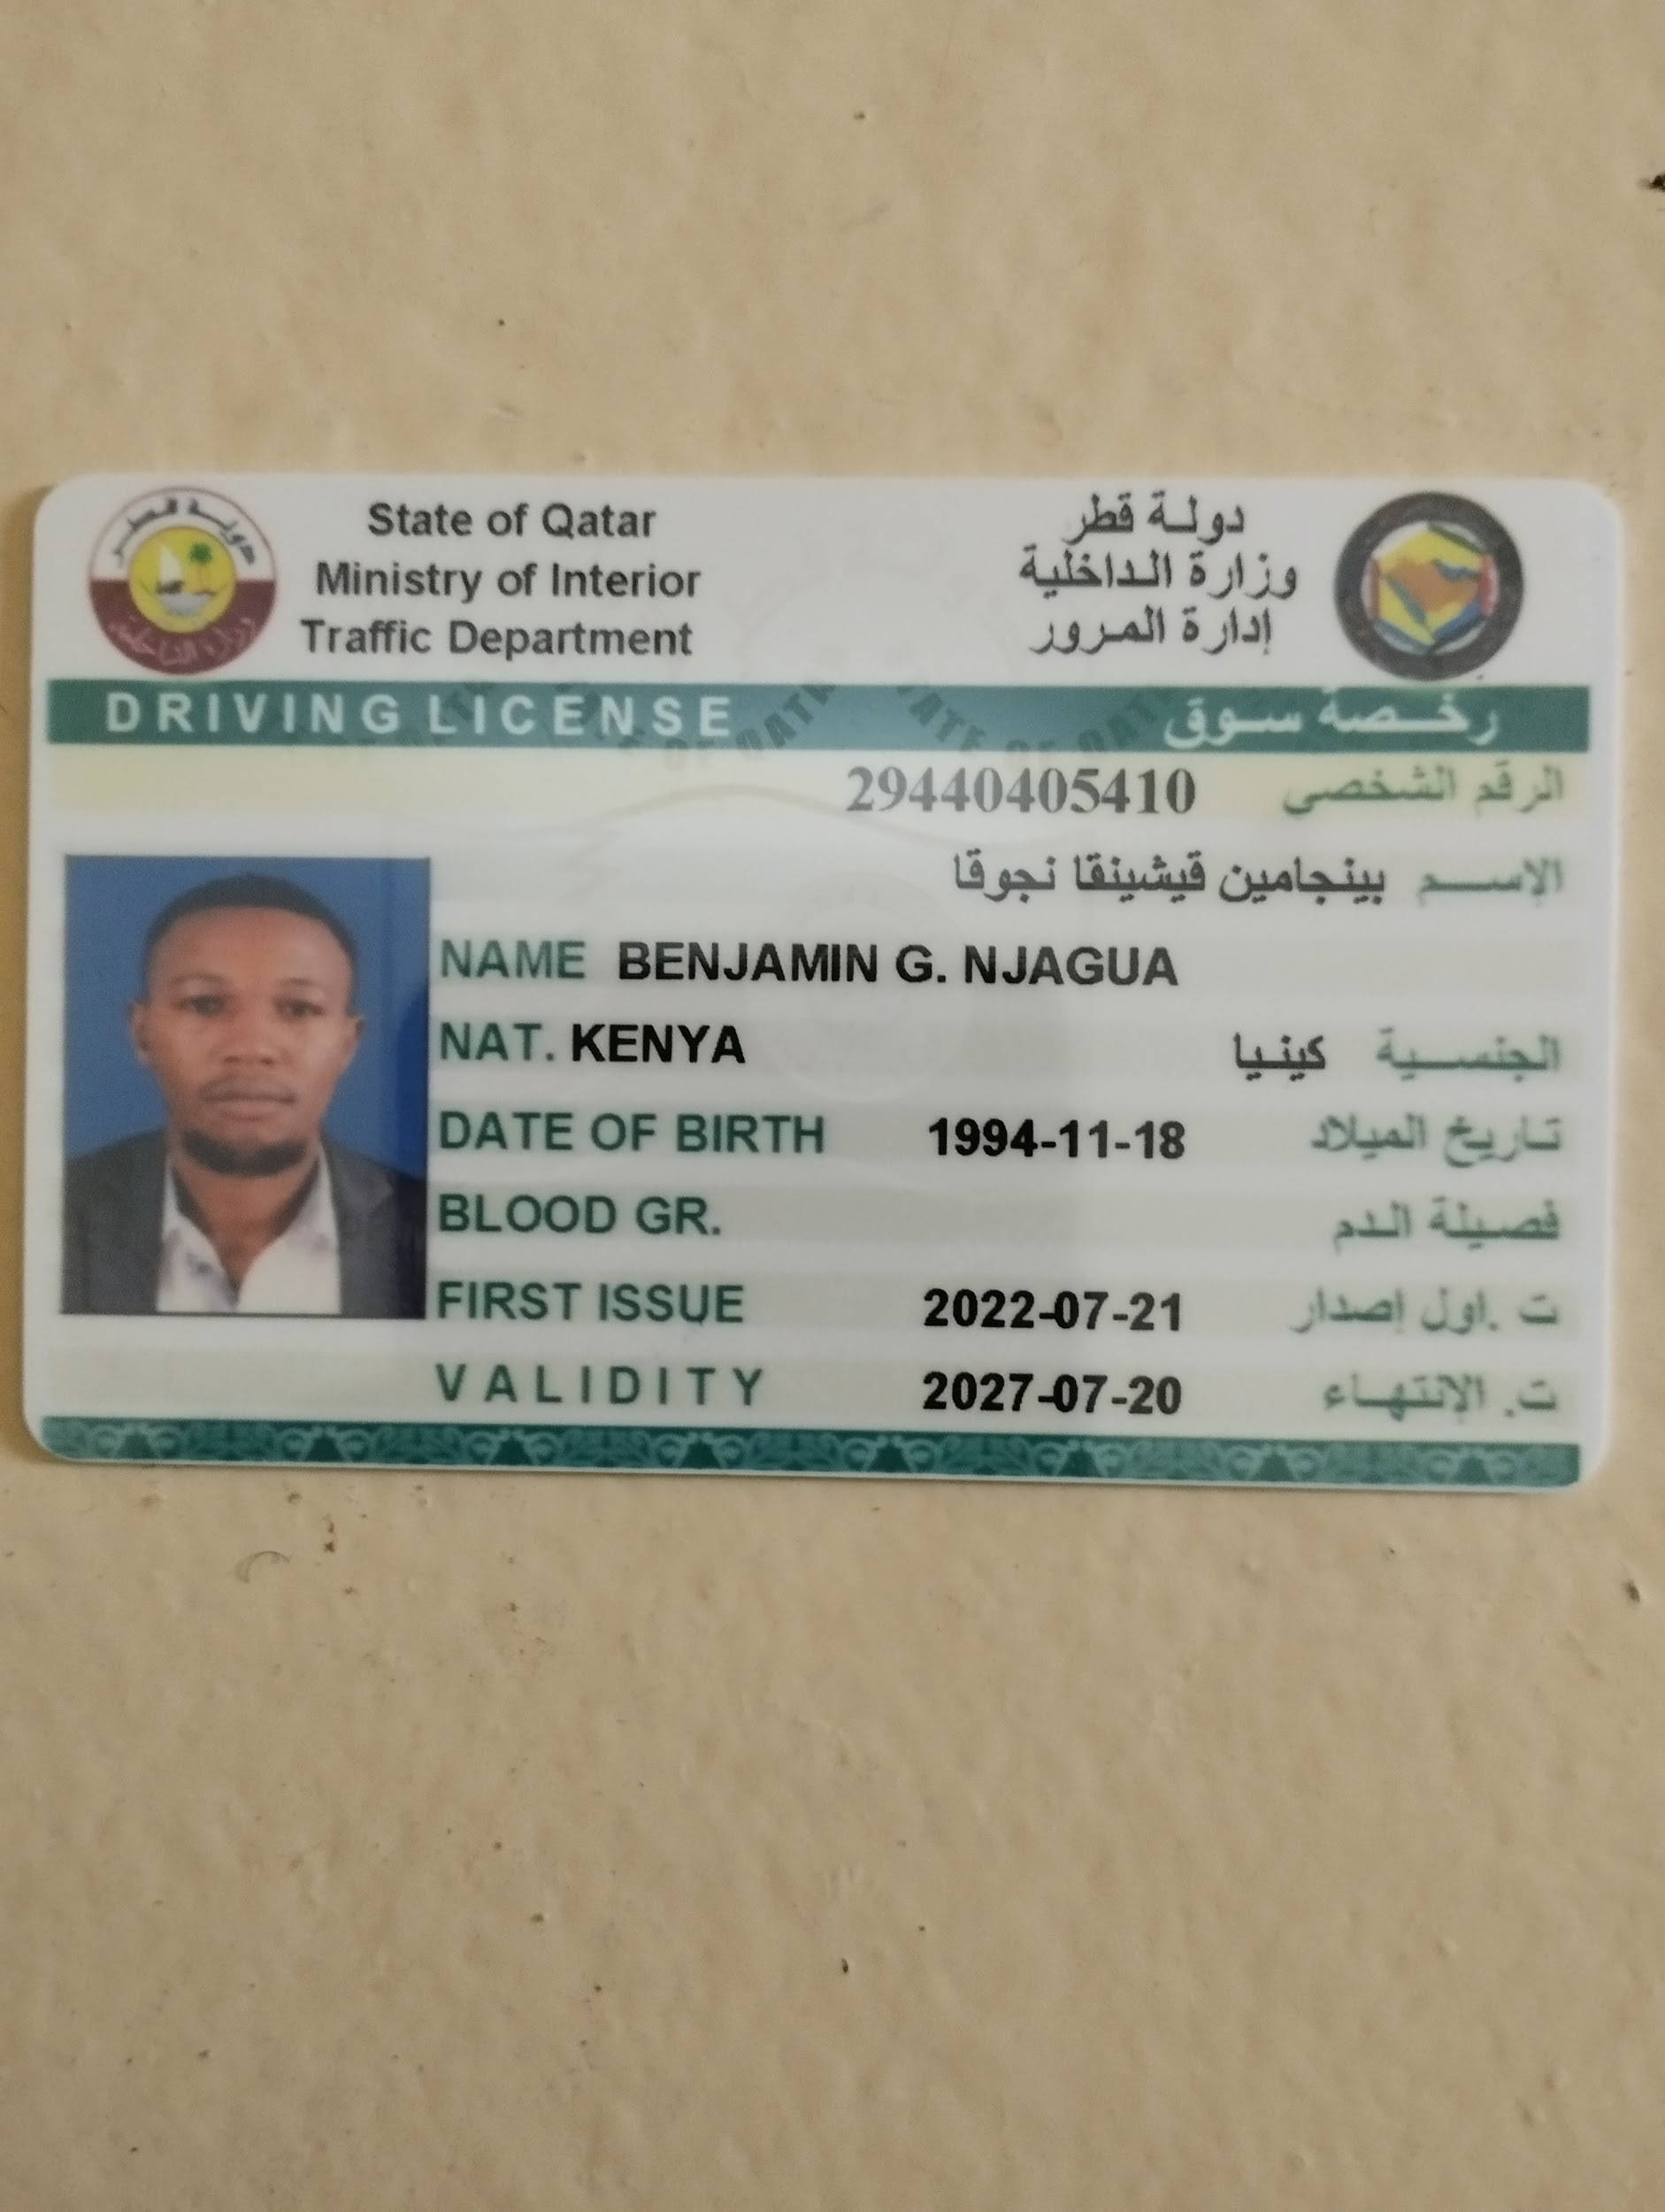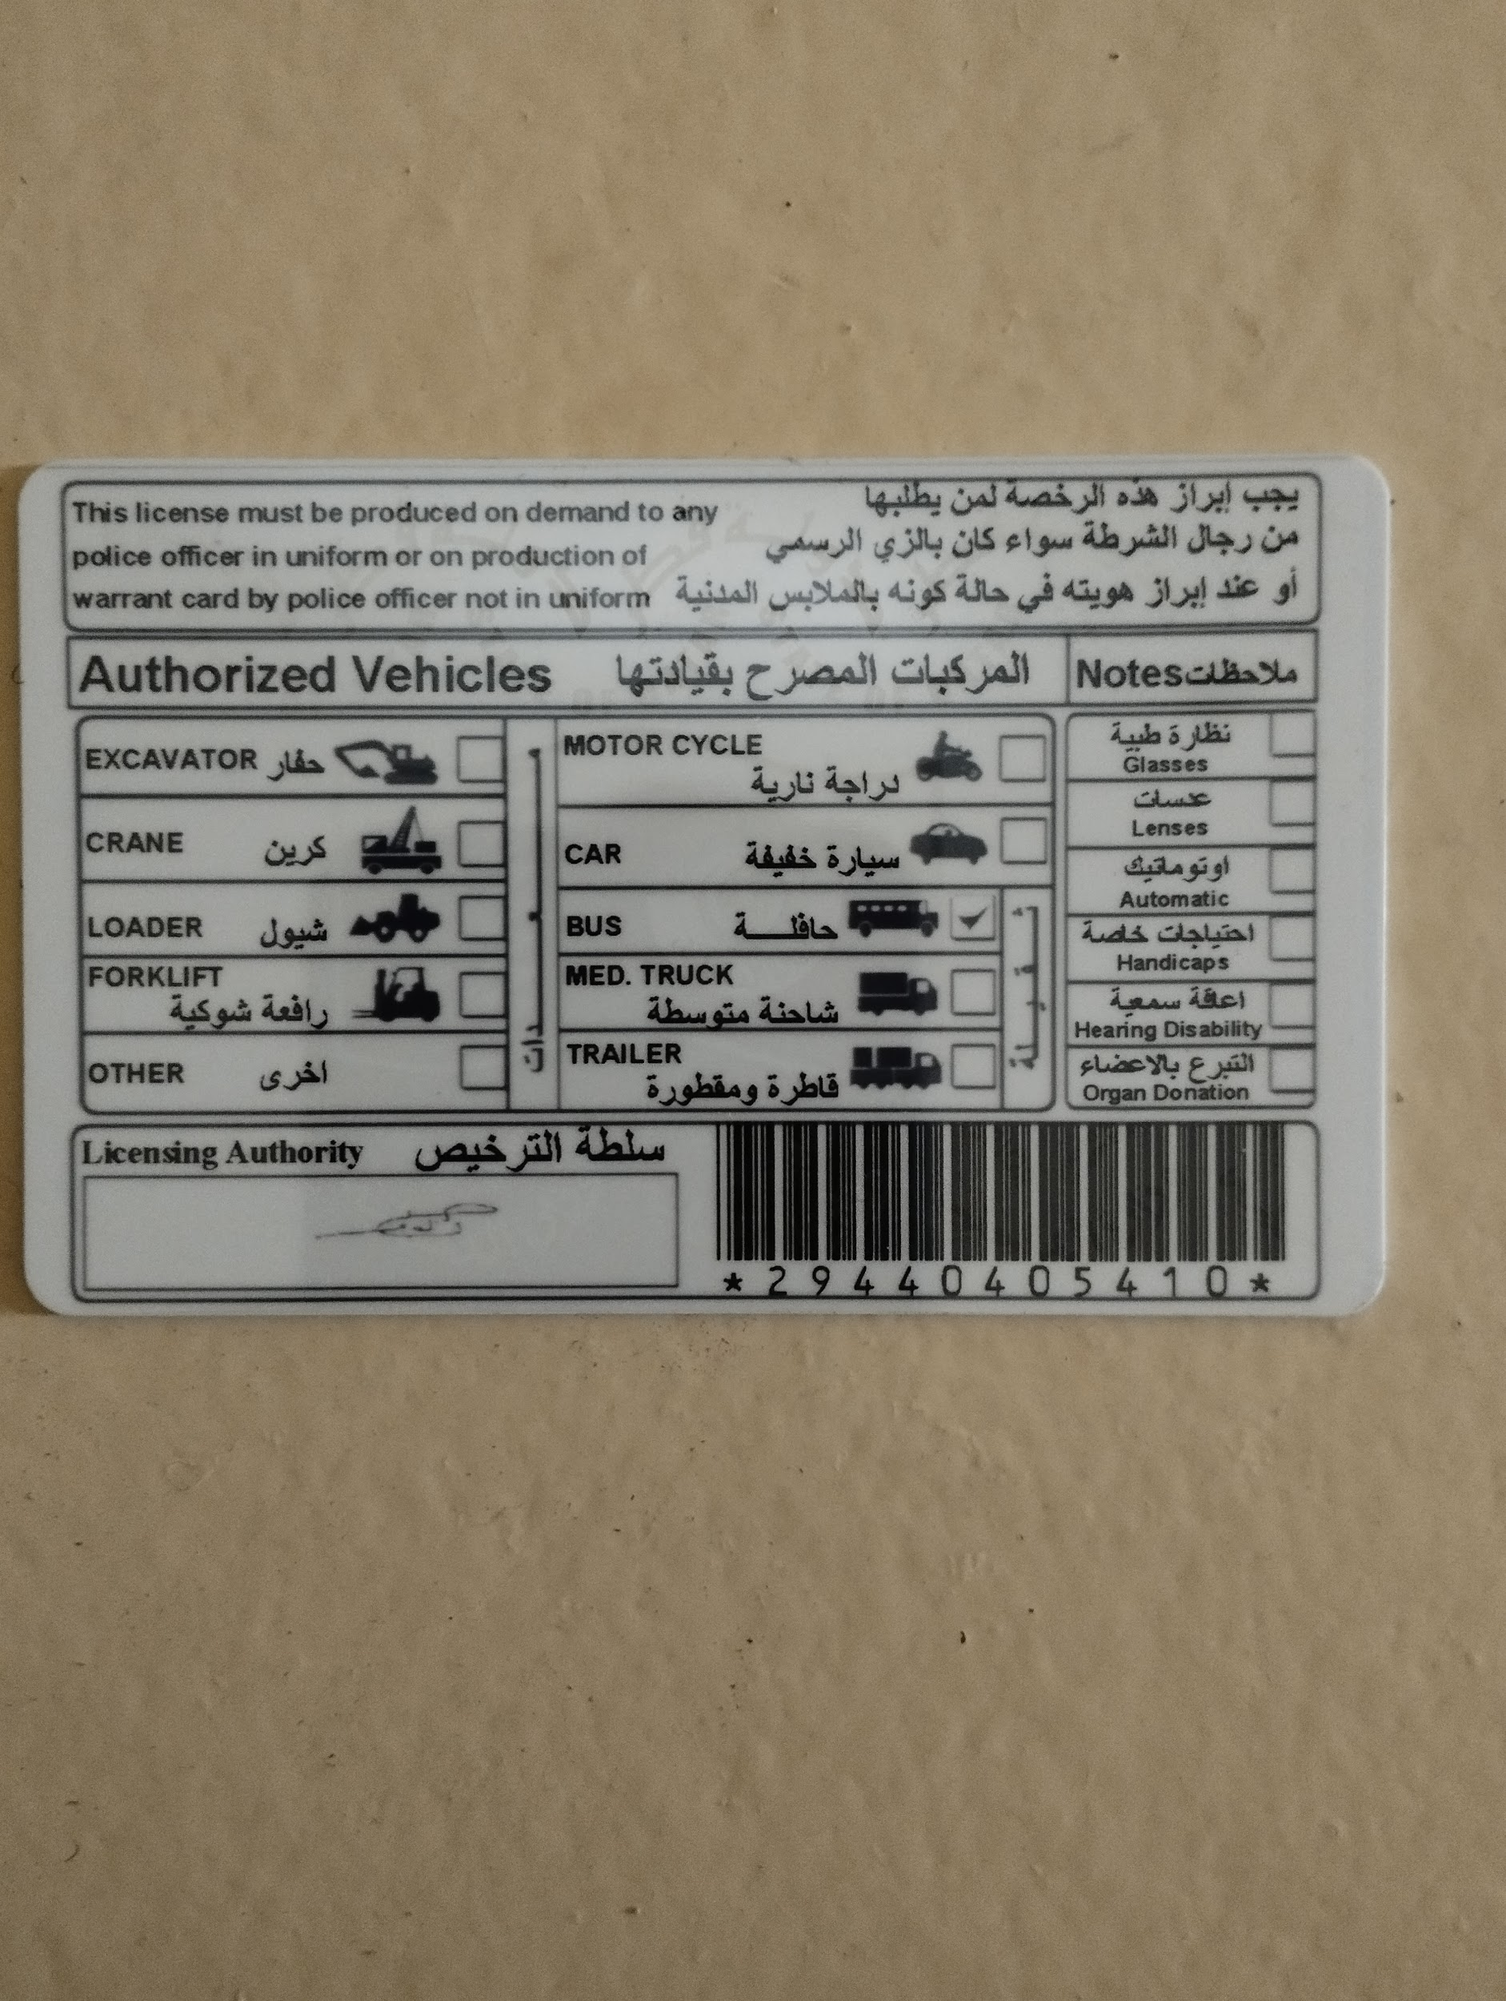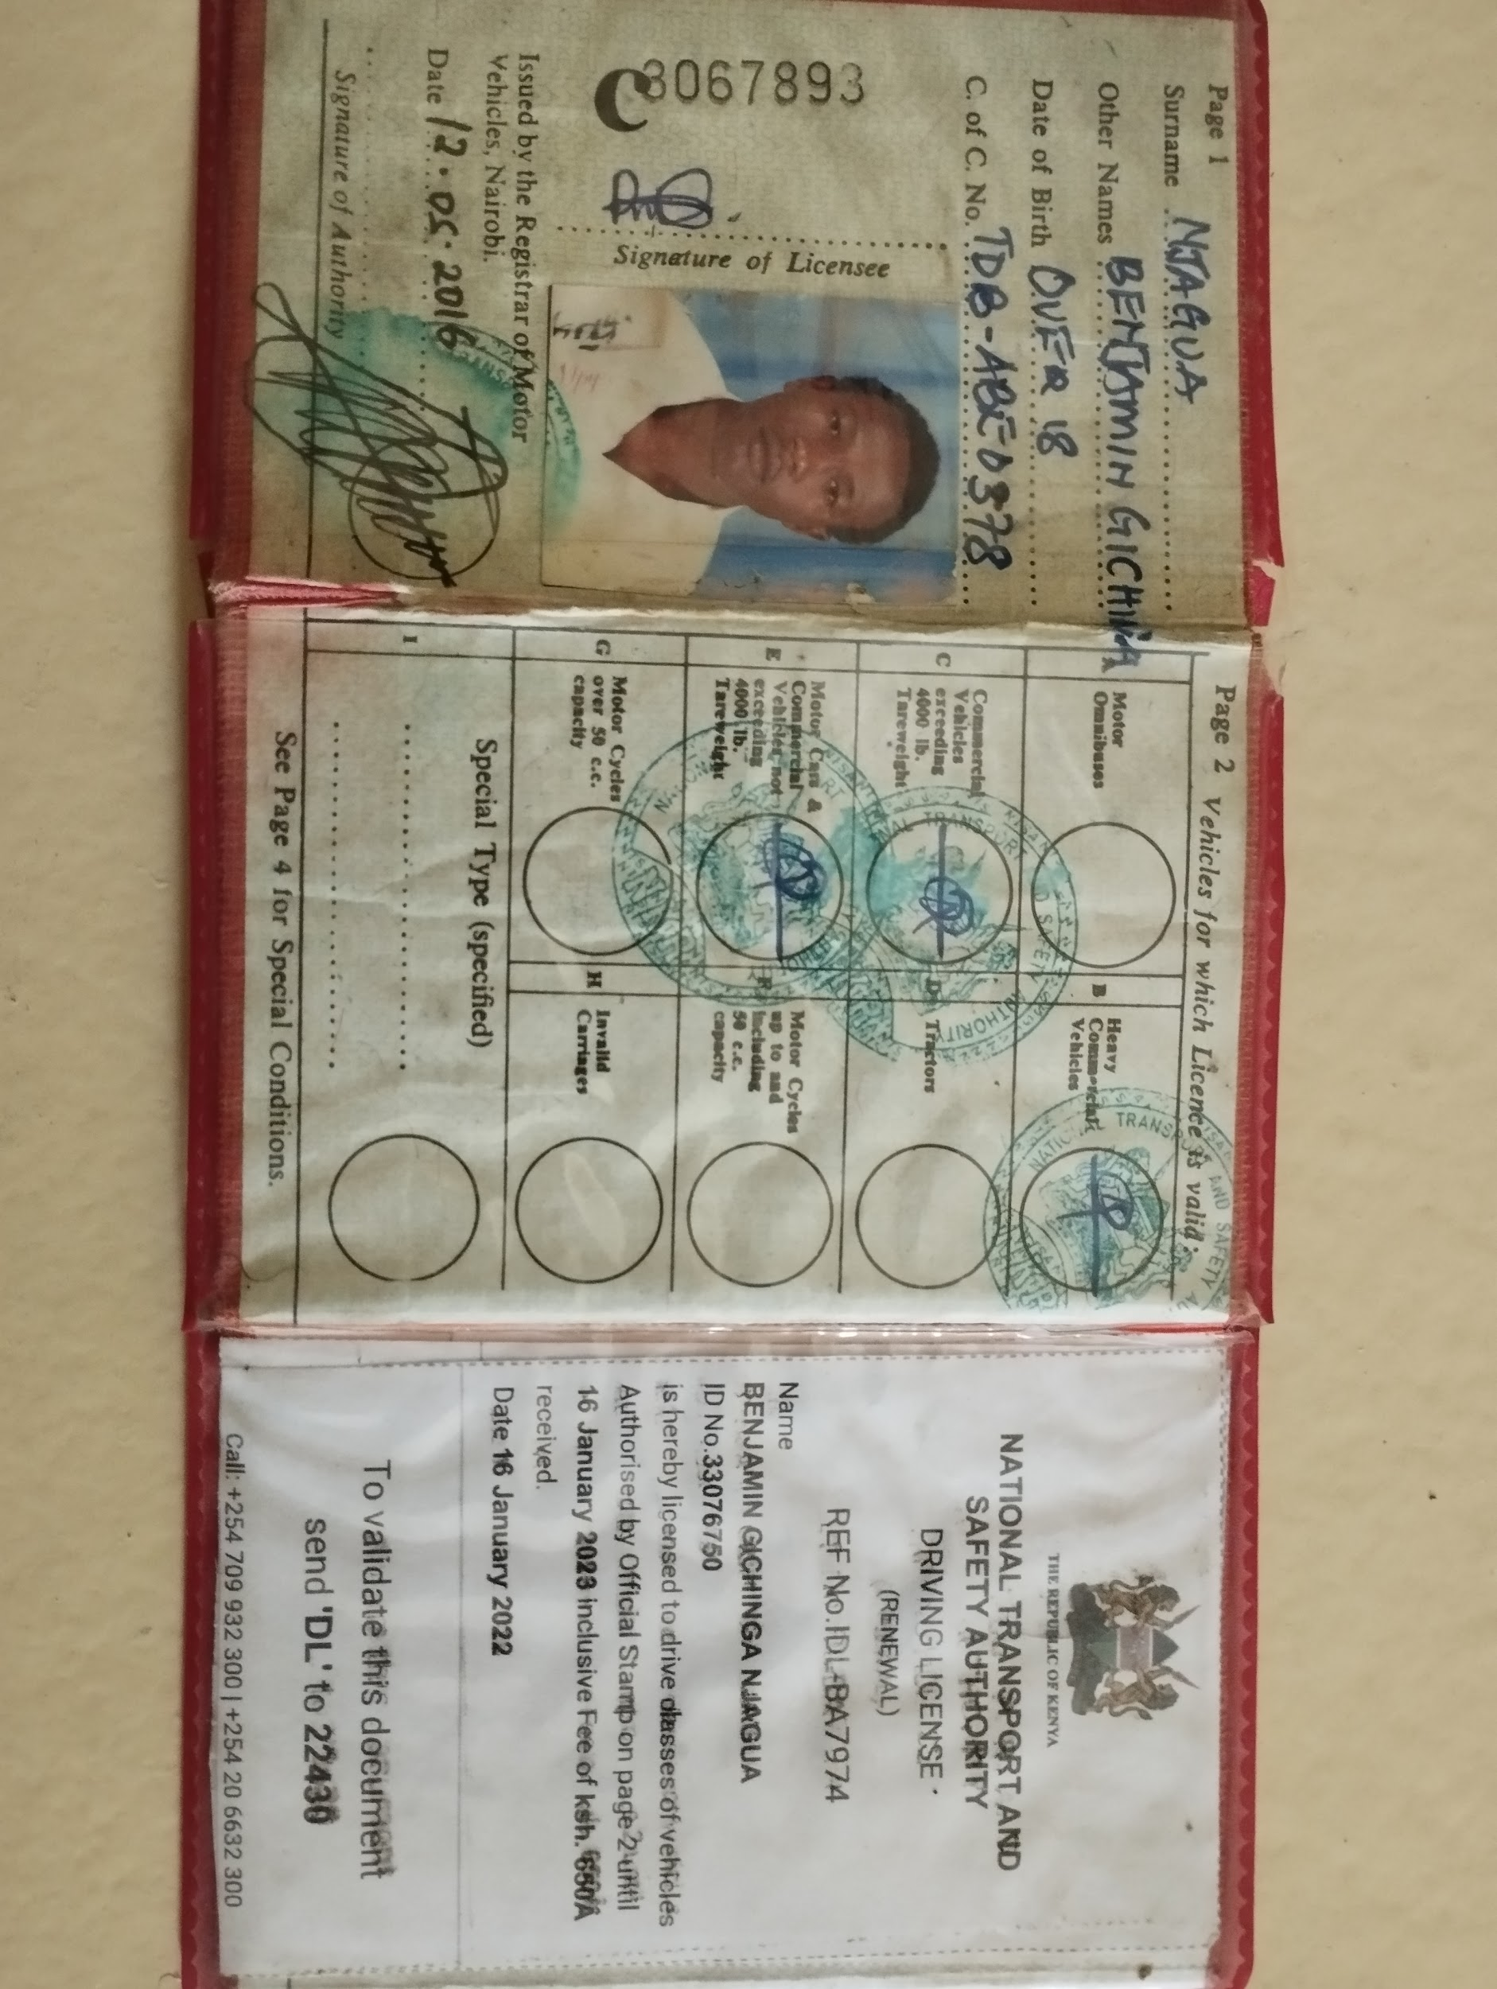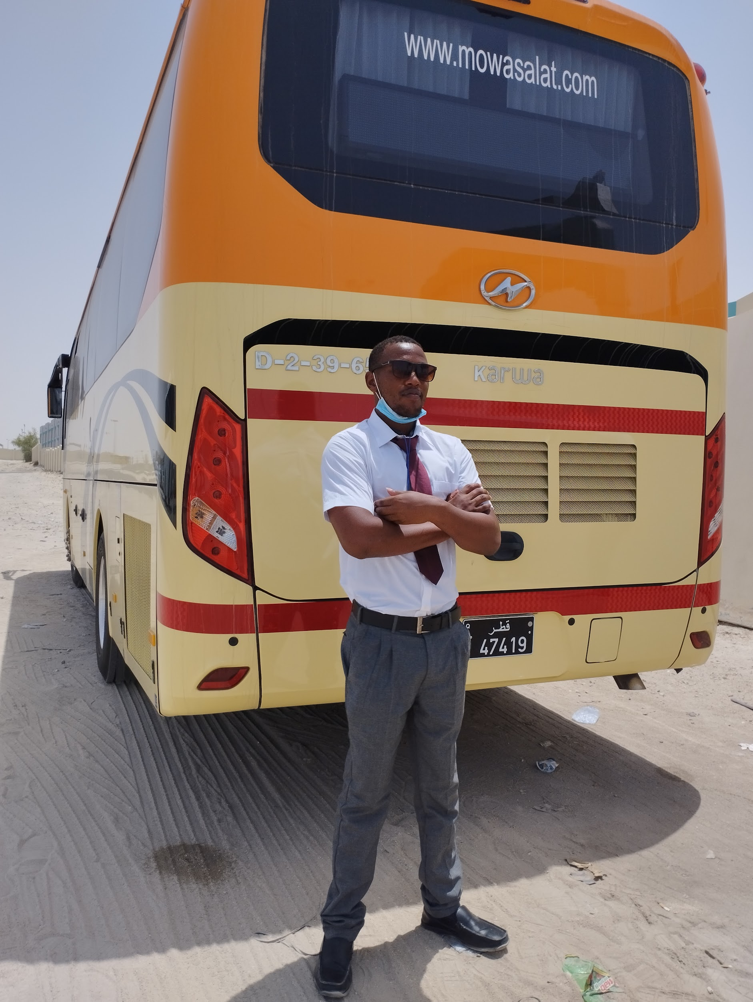**CURRICULUM VITAE**

**Name : Benjamin Gichinga Njagua**

**Date of birth: 18/11/1994**

**Gender: male**

**Nationality: kenyan**

**Marital status: single**

**Religion: Christian**

**Tel: +254716762690 /+97450587686**

**Email: benjaminnjagua1994@gmail.com**

Apply for: driver position

**PROFESSIONAL SUMMARY**

* Utilizing my gained skills and knowledge to meet set goal thus contribution leading to success of any organization.

**PERSONAL PERCEPTION**

* Hardworking and energetic with excellent communication skills.
* Excellent ability to understand and carry out instructions tactfully
* Great ability to work as part of a team
* Ability to relate courteously with customer and co-workers.

**EDUCATION BACKGROUND**

**2014 : Wa Jimmy Driving School**

Driving Licease BCE

**2010 -2014 : Kimuri Secondary School**

Kenya Certificate of Secondary Education

**2002 – 2009 : Naivasha Boarding School**

Kenya Certificate of Primary Education

**WORK EXPERIENCE**

**2022 : FIFA WORLD CUP**

**2015 -2021 : Gachuki Transporters**

**Position: Driver**

**Duties & Responsibilities:**

* Load and unloads guests luggage safely
* Demonstrated ability to keep the vehicles clean
* Transport cargo to different places safely
* Make minor repairs as and when necessary
* Drove company staff and clients to and from meetings or drop and pick them from destination
* Conducted vehicle inspection checks and took vehicles for service when due.

**HOBBIES**

* Travelling
* Driving
* Soccer

**REFEREES**

**Fredrick Thiongo**

**Tel: +254 791701744**

**Evalyne Abei**

**Tel: +254707266443**