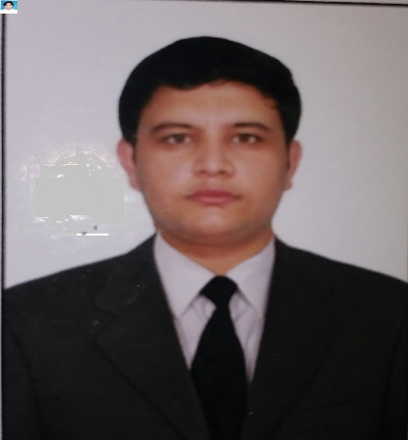  Imran  Khan | Villa 88,building no 19,street no 908,zone 91,ezdan 21,al wukair ,alwakra qatar  +97470609632  Imrankhanik9090@gmail.com
Seeking a challenging & growth oriented position in a reputable and progressive organization that offers a dynamic environment, a stable career path and an opportunity to apply my qualification and experience to the fullest and prove myself by being a part of further growth of the organization
Personal Information
- Father Name: Noor Hashim
- Date Of Birth :5/4/1995
- NIC NO : 17101-2398964-5
- Domicile: District Mohmand
- Marital Status: Single
- Nationality: Pakistani
- Religion : Islam
- Passport No: FA4159641

Skills

Social Worker

Criminal Lawyer

Civil Lawyer

Family Lawyer

Services Lawyer

Experience

2017 to 2023

Lawyer / District & Session Court Peshawar,KPK,Pakistan.
Dealt with different criminal, family, civil & services suites at District & Session Court

Education

2010

S.S.C/ BISE Peshawar,Peshawar Model School Boys 2,Warsak Road ,Peshawar,KPK Pakistan

Grade: A +

- 2012
- F.Sc/ BISE Peshawar,Peshawar Public School & College,Warsak Road Peshawar,KPK Pakistan
- Grade :A

- 2017

- LLB Shariah &Law/Islamia College University ,Peshawar,KPK,Pakistan

- C Gpa:3.65/ 4

Activities
- Social work
- Seminars
- Women Rights
- International Humanitarian Law
- Women Harassment

- Languages
- English : Speak/ Read / Write
- Urdu :Speak/ Read / Write
- Pashto: Speak /Read /Write

- Strength’s
- Hard Working
- Dedicated
- Loyal
- Honest
- Punctual

