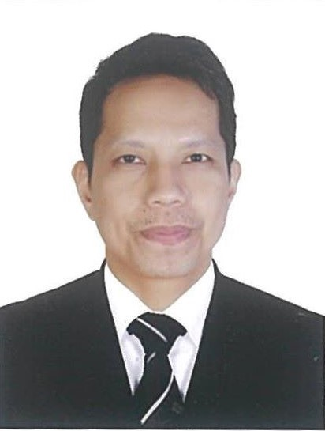

MICHAEL B. MORALES

*Thumama Villa 01 (B) Flat NO. 07 Street No. 974*

*Al Thumama, Doha, Qatar*

*Mobile No: +974 6647 0545*

*E-mail: morales_mykel11908@yahoo.com*

**POSITION DESIRE**: Any position that fits my qualification.

# OBJECTIVE

To acquire a job that will further enhance my skills; to gain exposure essentials to my career advancement; to be part of your company that values the capabilities of its people and has a desire for continuous improvements and help the company to achieve its goal.

# SUMMARY OF QUALIFICATION, SKILLS & ABILITIES

* Knowledge of Standard Procedures in receiving, storing, inventory and releasing of items; Personal computer skills. (Microsoft Excel Worksheet)
* Participate in proactive team efforts to achieve departmental and company goals. Physically capable of performing duties assigned.
* Ability to read and comprehend single instructions, short correspondence and memos; takes great pride in completing a job with accuracy and effectiveness.

# WORK EXPERIENCE

**May 22, 2018 – January 31, 2025 Trieagle Cargo Service LLC**

FF-25-10DSC Bldg. Port Saeed Road, Deira Dubai U.A.E

# Office / Logistics Support

* Handling Incoming calls and other communications. Greeting and Answering Inquiries of clients and visitors.
* Performing general office duties and errands (such as Cleaning Office spaces and buying office supplies)
* Managing filing and keeping of office files/records (such as SOA records of the clients) and updating using Microsoft Excel. Assisting Admin in managing filing records and office files. Updating paper works using Microsoft Excel.
* Keeping of office commercial and Employee Records (Trade License, Tenancy Contract, Establishment Card, Visa etc.) and ensure timely renewal arrangement to avoid any fines.
* Responsible for sending SOA Invoices to clients and to follow up payment thru email or phone call and for collecting Cheques/Cash Payments from the client's office, going to bank for withdrawal and payment deposits)
* Responsible for Collection of Original Documents (Stamped & Hand signed Commercial Invoice & Packing List) from their office for Customs Submission purposes, and for processing of client's documents including submission of Bill Of Entry using Dubai Trade of our clearing agent partner.
* To communicate to Shipping Lines for the availablity of Delivery Order and Status of the shipment of our clients. Responsible for handover of clients Original Documents (including BOE, D.O, B.L, Invoice and Packing List) to OL Dubai for Customs Submission (As soon as documents are complete)

**February 04, 2014 - March 06, 2018 Profi-Car Lubricants UAE LLC**

Executive Tower D, Office 1801, Aspect Tower, Business Bay, Dubai U.A.E

# Storekeeper

* Performs works involving the receiving of orders from ENOC/EPPCO Sites and Local Markets thru the Head Office.
* Preparing, arranging and issuing of all orders (Such as Car Additives, Oils & Battery) to Salesman, assisting in loading of the items to delivery vans and take their signature to ensure that the items received are complete & in good conditions.
* Responsible of receiving shipments and unloading of all items from container, checking of new arrived items for visible damages and shortage.
* Moving and storing of all items (Such as Car Additives, Oils & Battery) to the proper area in the warehouse using either manually mechanical handling equipment such as hydraulic pallet trolley or forklift.
* Keeping the records/amount of all items in the warehouse also the Delivery Invoice, Order Confirmations and Goods Returned Form from Sites/Local Markets (Good Condition Items & Damage Items).
* Responsible for checking of Battery Ratings (Volts, CCA & Acid), recharging of batteries if is in low voltage. Maintaining the safety of all items stored, cleanliness and orderliness in the warehouse.

**June 25, 2006 – July 16, 2013 Thyssen Krupp Elevator UAE LLC**

Dubai Intl. Airport Expansion Project, Phase 2 & 3, Dubai U.A.E

Yas Mall Project, Yas Island Abu Dhabi U.A.E

**Material Distributor (Logistics)**

* Responsible for receiving and unloading of all Elevator, Moving Walkways and Escalators materials in container truck. checking that the correct quantity and type of items have been received
* Signing the delivery form (Packing list), once satisfied that the materials (electrical and mechanical equipment) are complete or in good conditions; recording any damaged, missing or faulty items.
* Keeping records (often computerized) and overall responsibility of the document of all received, distributed, missing and damage materials/items and sending the report to the head office.
* Moving and stocking of materials (electrical and mechanical equipment such as hand tools, consumable and non-consumable items) to the correct shelves and storage area in the warehouse and in site either manually or using mechanical handling equipment such as hydraulic pallet trolley or forklift.
* Supervising and conducting safety briefing to supply personnel, forklift and truck drivers before the activity prior for delivery and shifting of materials from the warehouse to site; Coordination with area engineer (main contractor) to prepare safe temporary storage area on site.
* Ensure that the materials are properly arranged and stored with safety measure; Preparing a daily job report submitted to the operation manager for allowing him to know the daily activity in the site and in warehouse.
* Maintaining the amount/numbers of stock (Elevators, moving walkways and escalators materials/equipment/items) by doing weekly inventory and re-ordering if stock levels falls too low.

## EDUCATION

1998 - 2001  **Philippine Maritime Institute Colleges** Sta. Cruz, Manila Philippines

# Associate in Marine Transportation (Major in Marine Navigation)

## CERTIFICATION AND TRAINING

# Mariners Polytechnic Training Center

Noveleta, Cavite Philippines

April 2 – 7, 2001

# “Basic Safety Courses and Personal Safety & Social Responsibility”

# Admiral Maritime Training Institute of the Phils. Sta. Cruz, Manila Philippines

January 31 – February 26, 2002

# 

# “Navigational Watch, Shore Based Fire Fighting for Tankers and General Tanker Familiarization”

# 

# Prime power Manpower Services

Makati City, Philippines

January 19 – 24, 2004

**“Basic Housekeeping Operations Skill”**

## PERSONAL PARTICULARS

**Age**  : 44 Years Old **Civil Status** : Married

**Birth Date** : December 8, 1980 **Birth Place** : Caloocan, City

**Nationality** : Filipino **Passport No** : P5734344B

**Visa Status** : Family Visit Visa