Curriculum Vitae

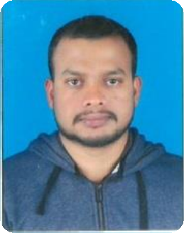

# RAMANAN VAINTHARASA MEGANATHAN

+974 31248019

[ramananraku94@gmail.com](mailto:ramananraku94@gmail.com)

# Objective:

A challenging position in a reputed organization for utilization for utilizing my knowledge and whilst developing my skills preferably a job that allows me to broaden my vision and sharpen my skills.

# Strengths

* Total commitment and dedication to the organization in a systemized manner
* Self-confident and grasping power, ability to get along with people well, trustworthy
* Time management skills with the ability of effective multi-task and work to tight deadlines.

# Educational qualification

* High School passed from Srilanka

# Work Experience

* 9 years Worked as Security Guard in European guardians - Qatar
* 6 months worked as Private Security in FIFA World cup- Qatar
* 1 year 6 months worked as Driver in Souq al Baladi Hypermaket - Qatar

# Personal profile

Name Nationality Date of birth

Gender

: RAMANAN VAINTHARASA MEGANATHAN

: Srilanka

: 06/10/1994

: Male

Marital status : Married

# QID & Passport Details

Qid Number 29414400626 Passport Number : N9376003

Expiry : 04/03/2032

License : valid medium truck Qatar license

Visa Status : transferable with NOC

**Language known**

* Arabic
* Tamil
* English,
* Hindi (Urdu),

# Declaration

I hereby assure you that all the above – mentioned information is true and correct to the best of my knowledge and belief