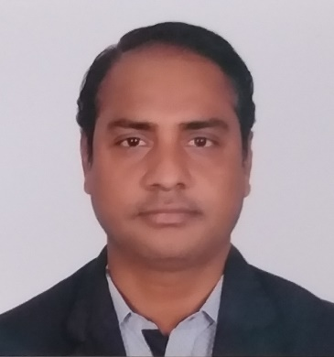
KHURSHID ALAM
Present Address:

Sanaiya Street 50, Industrial Area
Gate no.149, Doha Qatar

Mobile no: +91 7595862089 / + 974 70427594
+ 91 7595862089 / + 974 70427594
Email address: khurshid2012alam94@gmail.com
Applied for: Workshop Supervisor

CAREER OBJECTIVE
I have experience of handling any kind of situation, seeking a position as a Workshop Supervisor to apply my physical strength, organizational skill and general problem-solving knowledge to ensure the highest of warehouse management and no warehousing errors.

EDUCATION QUALIFICATIONS
Qualification | Name of institute | Board /University | Year
High Secondary | Free India High Secondary School Kolkata | West Bengal Board (W.B) | 2005
Matriculation | Garulia Mill High School | West Bengal Board (W.B) | 2003

WORK EXPERIENCE GCC-13 YEARS
Organization | Country | Designation | Duration | Year
Qatar Alpha Beton Ready-mix | Doha (Qatar) | Workshop Coordinator | 2 Years | Till
Roots Energy & Engineer Service | Doha (Qatar) | Data Entry cum Storekeeper | 1 Year | 2021
Al Rajhi Group of Company | Muscat (Oman) | Workshop Supervisor | 4 Years | 2017
Al Rajhi Group of Company | Muscat (Oman) | Storekeeper | 6 Years | 2011

TECHNICAL PROFICAIANCY

- ERP Software
- Tally ERP-9
- MS Excel
- MS Word
- GRN, MR, LPO
- Inventory
WORK RESPONSIBILITY
- Supervised workshop activities related to heavy equipment and transport fleet.
- Managed vendor relationships for parts and servicing, achieving quality repairs and timely delivery.
- Oversaw inventory of tools, parts, and consumables, ensuring availability and cost control.
- Handle customs clearance and documentation for import/export of mechanical parts.
- Ensured compliance with regulatory standards for vehicles maintenance and operation.
- Material Receiving and GRN Posting to Company’s System.
- Responsible for weekly and monthly workshop report to Department Manager.
- Arranging good housekeeping every day in the stores & warehouse.

PASAPORT DETAILS

- Passport no : U8207687 (ECNR)
- Date of issue : 31/12/2020
- Date of expiry : 30/12/2030
- Place of issue : Kolkata (INDIA)
- Old Passport no : J1028625 (ECNR)

SKILLS
- Hardworking, loyal, Quick learner, Quick at Grasping, Adaptable.
- Comprehensive problem-solving abilities and willingness to learn new things.
- Self-motivated, Resourceful, willing to accept responsibility and keen desire to learn.
- Reduced fleet maintenance costs through systematic scheduling and route optimization.
- Ability to maintain excellent customer relationships.
- Improved workshop turnaround time for repairs, leading to better equipment utilization.

PERSONAL DETAILS
- Name : KHURSHID ALAM
- Father’s name : MD. FAKHRE ALAM
- Place of birth : KOLKATA (INDIA)
- Date of birth : 10th APRIL 1986
- Sex : MALE
- Marital status : MARRIED
- Nationality : INDIAN
- Religion : ISLAM

LANGAUGE KNOWN

- ENGLISH, ARABIC, HINDI, URDU : ( READ, WRITE, & SPEAK)P
DECELARATION
I hereby declare that the above-furnished details are true to the best of my knowledge and belief.

Place: Qatar
Date: …….../…….../………… KHURSHID ALAM

