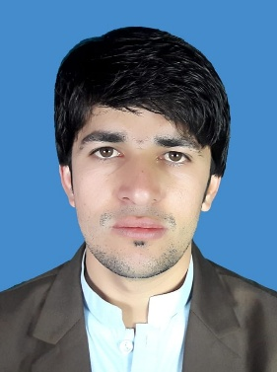 **SOHAIL REHMAN**

**LIGHT VEHICLE DRIVER**

**Mobile: 71042990**

**Current Address: Doha Qatar**

**Email Address: sohailrehman01@gmail.com**

**OBJECTIVE**

Diligent and safety-oriented Driver with 8 years of experience including 1 year in Qatar, delivering products as required to various locations. Ability to memorize delivery routes and destinations. Expert in time management and delivering.

**Summary and Skills**

**Vehicle basic maintenance, navigation, and understanding of traffic laws, customer service, time management, and communication, Route Planning, Safety Regulations, Defensive Driving,**

**WORK EXPERIENCE**

**Company: Al Mirqab Res**

**Position: Car driver**

**Location: Industrial area, Inkhalid, Azizzya, Abu Hamur, Bu Sidra , Al Seliya ( 2024 1st August 2024 to December 2024)**

**Company: Rafeeq Delivery**

**Position: Car Driver**

**Location: Al over Qatar**

**From December 2024 – Jun 2025**

**RESPONSIBILITIES**

Safely and efficiently transporting food orders from restaurants to customers. This includes tasks like loading, unloading, and ensuring the integrity of the delivery, as well as interacting with customers.

Operating vehicles safely, following routes, maintaining vehicles, and ensuring customer service.

**QUALIFICATIONS**

**Matric science**

**FSC science**

*From “KUST” kuhat university of science and technology*

**CERTIFICATIONS & LICENSE**

**• MS OFFICE**

• **OSHA** ( Occupational Safety and health Administration)

• **NEBOSH** : IG1and 2

• **CIT** ( Certificate of Information Technology)

**•Teaching Certificate** Two years experience

• **Qatar Driving License**

•**Certificate of Appreciation** ( Al Mirqab Restaurant and Bakery

•**Certificate of Appreciation**, ( Al Shaqab) member of Qatar foundation

**Languages**

English

Hindi

Arabic