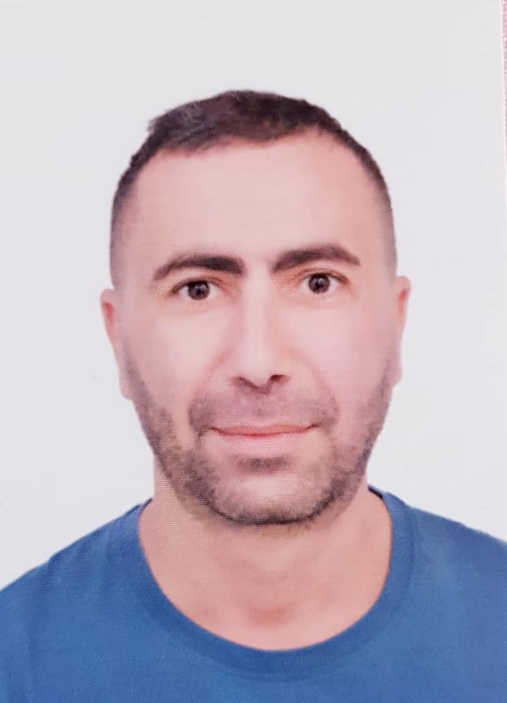 | Mustapha Ouzeri  WaiterHighly Reliable & Detail-Oriented Driver
profile  Highly reliable and detail-oriented professional with over 10 years of experience in customer-facing roles, adept at managing logistics, ensuring timely service, and maintaining high standards of professionalism. Possesses strong organizational and problem-solving skills, with a proven ability to handle responsibilities efficiently and adapt to various situations. Eager to leverage excellent time management and customer service abilities in a challenging driver role.  Contact  PHONE: +974 66177259  QID: 28501200719  Adress:  Al Mansoura, Doha, Qatar  EMAIL: ouzerimustapha09@gmail.com  Languages  Arabic  French  English | DRIVING LICENSE  Type:Qatar Driving License - Light Vehicle  Number: 28501200719  First Issue: 29/06/2025  Validity: 28/06/2030  KEY SKILLS  - Time Management & Route Optimization: Proven ability to manage schedules and prioritize tasks efficiently to ensure timely delivery and service.  - Customer Service & Communication: Skilled in interacting professionally with customers, understanding needs, and resolving issues diplomatically.  - Problem-Solving & Adaptability: Capable of handling unexpected situations and finding effective solutions under pressure.  - Detail-Oriented & Safety Awareness: Meticulous attention to detail in maintaining standards and a strong understanding of safety protocols (transferable to vehicle maintenance and road safety).  - Team Collaboration: Experience working effectively within a team to achieve common goals.  - Multilingual Communication: Arabic (Native), French and English, facilitating clear communication with diverse individuals.  WORK EXPERIENCE  Delivery and Logistics Manager  Glass & Mirrors Company - Blida, Algeria | 2008 – 2024  - Ensured prompt and accurate delivery of orders, demonstrating strong time management and efficiency.  - Maintained high standards of service and appearance, including regular inspection of service items (transferable to vehicle cleanliness and maintenance).  - Built strong rapport with customers, indicating excellent interpersonal and customer service skills crucial for client interaction.  - Managed operations efficiently, showcasing organizational abilities.  - Assisted with managing large customer volumes, especially during peak hours, highlighting ability to handle high-pressure environments.  - Resolved customer concerns diplomatically, indicating strong problem-solving and communication skills.  EDUCATION  Khazrouna High School  2001-2003  Secondary School Certificate  Science program  Interest  - Sport  - Food  - Culture  - Volunteering  - Maners

