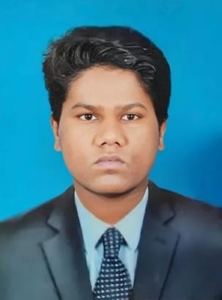  PERSONAL DETAILS  Date of Birth : 23/04/1995 Nationality : NEPAL Gender : Male Marital Status : Married  PASSPORT DETAILS  Passport no :PA2021218 Expiry Date : 04/11/20233  QATAR ID DETAILS  ID No 29552410175  Expiry Date : 13//09/2025  QATAR DRIVING LICENSE DETAILS  License No: 29552410175 First issue date: 22/09/2019 Date of expiry: 27/08/2029  SKILLS  - Situational awareness  - Physical fitness  - Emergency response  - Conflict resolution.  - Professionalism  - Teamwork.  - Critical Think  LANGUAGE SKILLS  - English  - Hindi  - Arabic |  | NUR MAHAMMAD RAIN   +974 30718124  Email: mdnoor775608@gmail.com Doha, Qatar  POST APPLIED FOR: LIGHT DRIVER  OBJECTIVE  A purposeful individual willing to accept a challenging position in a progressive, Growth oriented and dynamic organization, where I can utilize enhance my talent, Knowledge and skill for significant contribution to the organization.  EDUCATION  - 11th Class Passed.  WORK EXPERIANCE  - SUWAQ Limousine. in Qatar  Position: Light Driver Period : For 03 Years.  - Carrier Company. In Doha Qatar  Position: AC Technician Period : For 02 Years.  Duties And Responsibilities:  - Vehicle Operation: Safely drive the vehicle according to traffic laws.  - Maintenance Checks: Perform routine checks on the vehicle (oil, brakes, lights).  - Passenger Safety: Ensure all passengers wear seatbelts and follow safety protocols.  - Route Planning: Plan efficient routes to avoid delays.  - Communication: Stay in contact with dispatch or management.  - Record Keeping: Maintain logs of trips, mileage, and fuel consumption.  - Emergency Handling: Know how to respond to emergencies or vehicle breakdowns.  .PERSONAL PROFILE  - Extremely hard working, self-motivated and able to work independently.  - Keep excellent interpersonal relations with colleagues and ready to help  - Very energetic result oriented and organized.  - Efficient and well- behaved person.  DECLARATION  I hereby declare that all the information furnished in this document is true my knowledge and belief

