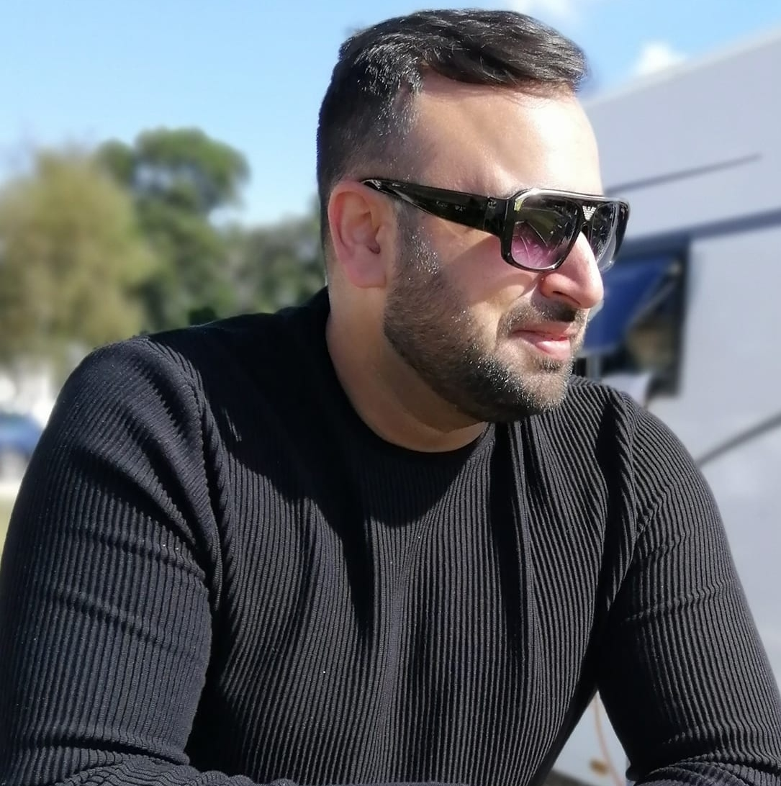 |  | Salman Ashraf  Generator Engineer
A highly driven Electrical Engineer with extensive experience in the power generation industry. Expertise in servicing, troubleshooting, and maintaining diesel and gas generators in high-pressure environments. Proven ability to manage and lead teams, handle critical tasks under tight deadlines, and resolve complex technical issues. Recognized for excellent customer service, problem-solving skills, and delivering exceptional results under challenging conditions.  Contact  PHONE:  00447462168292  EMAIL:  Salmanashraf85@yahoo.co.uk  Hobbies  Gym  Swimming  Travelling |  | Core Competencies  - Diesel & Gas Generator Maintenance & Installation  - Engine Diagnostics & Fault Resolution  - Emergency & Preventive Maintenance  - Project Management & Team Leadership  - Customer Service & Technical Support  - Electrical Troubleshooting & PLC Programming  - Load Testing & Commissioning  - Health & Safety Compliance  Professional Experience  Ingram Installations  2024-Present  Field Service/installation engineer  - Install and commission diesel and gas generators, ensuring smooth system setup and integration.  - Perform routine maintenance and repairs to keep equipment running efficiently  - Troubleshoot and diagnose faults, providing quick and effective solutions.  - Provide customer support, including training on generator operation and maintenance  - Maintain accurate service logs, reports, and documentation for all work completed.  - Travel to various locations to carry out field service operations and installations.  Gap Hire Solutions – Warrington  Regional Generator Engineer  2023–2024  - Working on the HS2 project, installing and maintaining diesel generators for high-demand infrastructure.  - Provide field services and troubleshoot breakdowns, ensuring continuous operation and minimal downtime.  - Maintain a positive client relationship, addressing service issues and ensuring high customer satisfaction.  Generator Power – Warrington  Field Service Engineer  2022–2023  - Managed a team of technicians to install and maintain backup power systems for football stadiums in Qatar ahead of the 2022 FIFA World Cup.  - Successfully provided backup power during the Women’s Champions League 2023 in Manchester.  - Delivered emergency response services and routine maintenance for United Utilities and other clients.  - Coordinated with clients to ensure seamless installation and operation of critical power systems.  Green Frog Genovate – Manchester  Site Engineer  2018–2019  - Managed daily operations of gas-powered generators, performing routine checks and troubleshooting issues.  - Ordered and installed replacement parts, ensuring minimal downtime and operational efficiency.  - Provided regular reports to the manager and ensured compliance with site standards and safety protocols.  Aggreko – South Sutton  Depot Engineer  2018–2019  - Conducted maintenance and fault-finding on diesel and gas generators, ensuring reliability and performance.  - Installed telemetry systems and GPS for generator tracking, improving fleet management.  - Provided diagnostic and repair support, ensuring all equipment met client requirements.  UKLST – Manchester  Administrator  2014–2018  - Handled administrative tasks, including interpreting and translating technical documents.  - Managed client inquiries and provided solutions, ensuring customer satisfaction.  Network Rail – Manchester  Security Guard  2013–2014  - Ensured the security and safety of construction sites, protecting railway property and personnel.  - Detected and prevented potential criminal activities, maintaining a safe work environment.  Al Futtaim Group – UAE  Senior Field Service Engineer  2012–2013  - Installed and maintained power generation systems, including turbines, switchgear, and street lighting.  - Worked with industrial machinery and equipment, including programmable logic controllers (PLC).  - Provided technical support for network infrastructure projects.  Sakr Power – Jebal Ali, UAE  Electrical Technician  2011–2012  - Serviced and maintained power generation and transmission systems.  - Worked with turbines, switchgear, and industrial machinery, performing repairs and troubleshooting.  Caterpillar Al Bahar – Sharjah, UAE  Electrical Technician  2008–2011  - Diagnosed and performed troubleshooting on various diesel generator sets (gensets).  - Gained expertise in genset components, conducted load tests, and utilized ET software for diagnostics.  Education  BA (Hons) in Business & Tourism Management (2024)  Manchester, United Kingdom  Diploma in Power Generation Course  Ap-tech College, Gujranwala — 2005-2006  Industrial Wiring  Punjab Technical Training Centre  Certifications  - Forklift Training (B1 B2)  - First Aid Certification  - Health and Safety  - Fire Marshals  - Safety Awareness  - Full UK & UAE Driving License  Technical Skills  - IT Proficiency: Microsoft Office, Windows OS  - Technical: Diesel and Gas Generator Systems, Telematics, GPS Installation, Load Testing, PLC Programming  - Communication: Skilled in managing customer inquiries, translating technical documents, and email communication.  Full UK and UAE driving license

