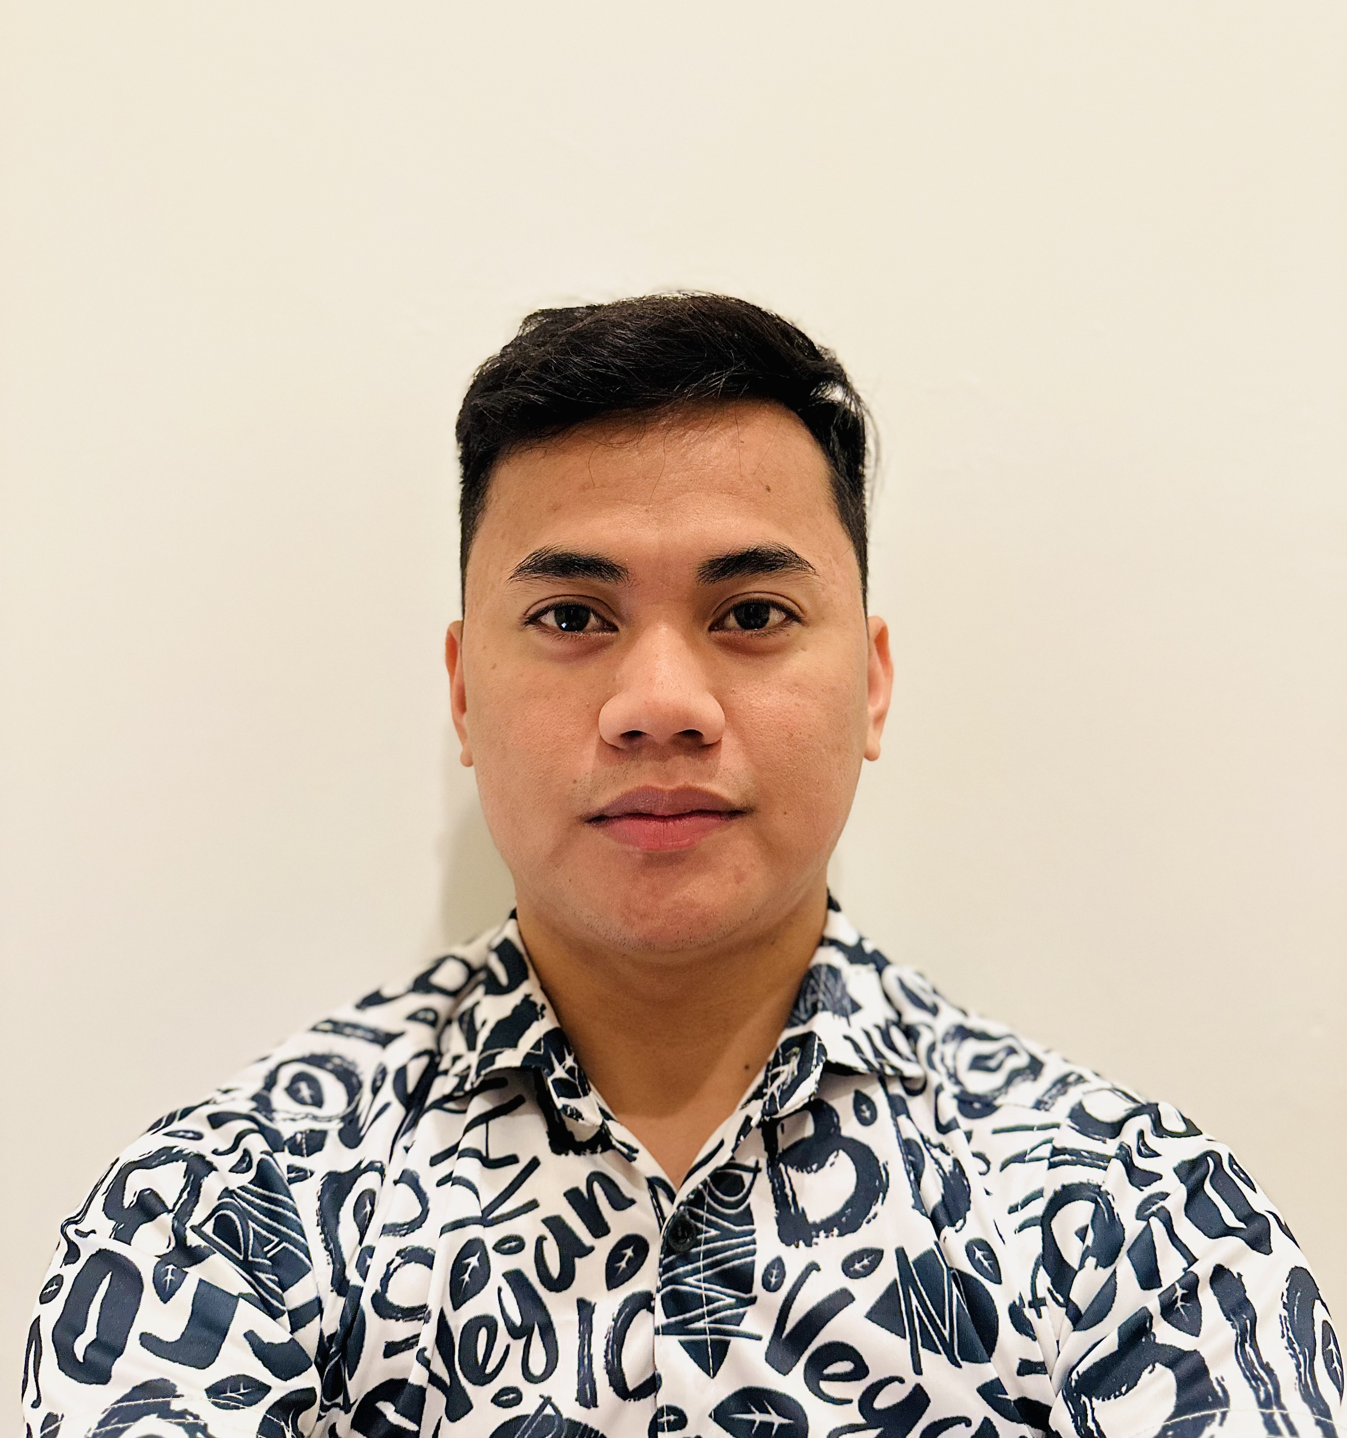**Jomar B. Rueda**

West bay Union Tower

36 street 15floor

ct No. +974 3394 5256

Email Address: [johmarrueda16@gmail.com](mailto:johmarrueda16@gmail.com)

**Education**

2015 – 2017 Associate in Office Management, National College of Science and Technology

2010 – 2014 Colegio De Salitran Molino Homes III, Dasmariñas, Cavite

2008 – 2009 Dasmariñas Bagong Bayan Elementary School

**Proficiencies**

2016 English Proficiency – Developing Communication

2015 Office Politics, How to Handle it Effectively

**Professional Experience**

**2024 Present. La dereach Chocolate swies**

**Salesman**

**. Assisting the customer and dealing**

**.making and arranging design of cholates**

**. Basrista**

**.Making coffee and cold drinks**

**. Kitchen making for sweet and baking**

**2021 – 2023 December Café, Doha, Qatar**

**Barista – Cashier**

* Greeting customers in a friendly manner and taking food and drink orders as well as taking payments
* Preparing and serving beverages such as drip coffee, espresso-based drinks, tea and other specialty drinks
* Answering customers’ questions about menu choices
* Promoting and recommending menu options to customers
* Tracking and ordering inventory for cafe and beverage supplies, such as coffee beans, milk, napkins and cups
* Maintaining espresso machines, grinders, coffee machines and other equipment by cleaning, troubleshooting and scheduling repairs

**2020 – 2021 ANDK Trading and Contracting Company, Doha, Qatar**

**Administrative Assistant**

* Answering, screening and transferring phone calls.
* Receiving and directing visitors and clients.
* Organizing meetings, travel and events.
* Preparing reports and documents.
* Maintaining filing systems and office equipment.
* Providing real-time scheduling support by booking appointments and preventing conflicts.
* Anticipate the needs of others in order to ensure their seamless and positive experience.

**2017 – 2019 BOWEN HILLS, Makati City, Philippines**

**Account Payment Officer**

* Creating and processing invoices
* Cross-checking invoices with payments and expenses to ensure accuracy
* Managing a company’s accounts payable and receivable
* Sending bills and invoices to clients
* Tracking organization expenses
* Processing refunds
* Working with collection agencies on overdue payments
* Communicating with clients regarding billing and payments

**Nov 2016 PhilHealth, Imus, Philippines**

**Office Staff – Training and Development**

* Update and maintain database, mailing, inventory, and filing systems, either by using computers or manually
* Route, sort, and open incoming mails
* Prepare outgoing mails and also answer correspondence
* Run errands and also deliver messages
* Order services, supplies, and materials
* Arrange appointments, manage calendars, and complete work schedules.

**Skills**

* Problem-solving
* Planning
* Detail-oriented
* Time Management
* Organized
* Team Player

I hereby certify that all above information is true and correct with the best of my knowledge and belief

JOMAR B. RUEDA

Your Applicant