**CAREER SUMMARY**

Skilled and detail-oriented Welder with over 9 years of experience in welding, fabrication, and metalworking. Proficient in a variety of welding techniques, including MIG, TIG, and Stick welding, with a strong focus on precision and quality. Experienced in interpreting technical blueprints and welding symbols to ensure accurate assembly and fabrication of metal components. Adept at performing quality control inspections to meet safety and industry standards. Committed to adhering to safety protocols and maintaining a clean, safe work environment. Proven ability to collaborate effectively with cross-functional teams to complete projects on time and to specifications.

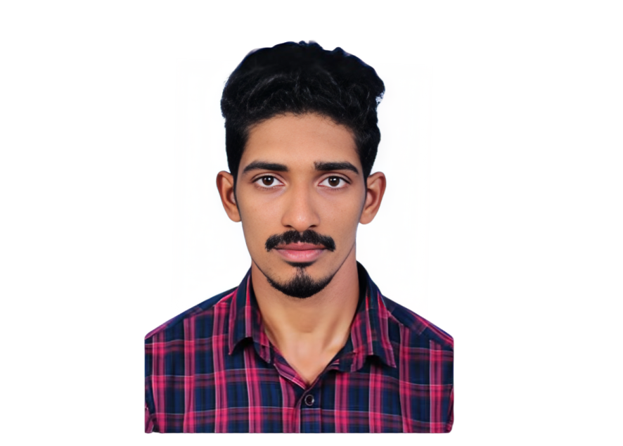

**LANGUAGES**

**English**

**Malayalam**

**Hindi**

**EXPERIENCE**

**MECHANIC | 2023 - PRESENT**

**VIRAAT MARINE**

* Perform regular maintenance and repairs on marine engines, ensuring optimal performance and longevity of the vessel's power systems.
* Conduct thorough diagnostics using advanced tools and equipment to identify mechanical malfunctions in marine systems, including engines, gearboxes, and auxiliary machinery.
* Disassemble, inspect, and overhaul mechanical components such as pumps, valves, and compressors, ensuring all parts are in good working condition and meet safety standards.
* Execute scheduled preventive maintenance procedures to reduce the risk of breakdowns and extend the lifespan of marine equipment and machinery.
* Adhere to all safety regulations and marine industry standards while performing mechanical tasks, ensuring all work is completed in compliance with company policies and maritime safety guidelines.

**WELDER | 2021 - 2023**

**YOJAKA (INDIA) PVT. LTD, MANGALORE, KARNATAK**

* Perform welding on metal structures and components, utilizing MIG, TIG, and Stick welding techniques to fabricate and assemble parts for machinery, ships, and other projects.
* : Read and interpret technical drawings and welding symbols to ensure precise welding and fabrication according to project specifications and industry standards.
* Inspect welded joints for defects such as cracks or porosity, ensuring that all welds meet safety standards and pass quality assurance tests.
* Adhere to safety protocols, using personal protective equipment (PPE) and following industry safety regulations to maintain a safe working environment during welding operations.
* Conduct welding repairs on damaged or worn metal components, restoring structural integrity and ensuring equipment functionality.

**EDUCATION**

**2014 DIPLOMA IN MARINE MECHANICAL FITTING**

National Council for Vocational Training

**2012 HIGHER SECONDARY**

Board of Higher Secondary Examination, Kerala

**2010 SSLC**

Board of Public Examinations, Kerala

**Time Management**

**Team Collaboration**

**Safety Compliance**

**Metal Fabrication**

**Blueprint Reading**

**Quality Control & Inspection**

**Welding Techniques**

**PERSONAL DETAILS**

**🖩** +91 9747884020, +97477145421 (Qatar)

🖄 naseeb.ali.5@gmail.com

Address : Azhupurath House

Perumanna Valakkulam P.O,

Malappuram, Kerala,

676508

Nationality : Indian

D.O.B : 19/06/1994

Gender : Male

Marital Status : Married

**NASEEB AZHUPURATH**

**Problem Solving**

**Attention to Detail**

**KEY SKILLS**

**MARINE MECHANICAL FITTER | 2015 - 2020**

**TEBMA SHIPYARD, MALPE, UDUPY, KARNATAKA, INDIA**

* Install and assemble mechanical systems and components on marine vessels, ensuring compliance with design specifications and industry standards.
* Perform preventive and corrective maintenance of mechanical systems such as engines, pumps, compressors, and piping systems to ensure optimal operation of the vessel.
* Read and interpret technical drawings, blueprints, and schematics to ensure accurate mechanical fitting and assembly.
* Diagnose and troubleshoot mechanical issues on ship systems, utilizing precision tools and testing equipment to ensure reliable operation.
* Adhere to safety protocols and maintain a safe working environment by following industry safety standards, including wearing appropriate PPE and ensuring machinery is properly locked out during maintenance.
* Conduct calibration and testing of mechanical systems and machinery to ensure systems are functioning within specified parameters.
* Ensure all mechanical fittings and repairs meet stringent quality standards and perform quality checks on completed work to verify correctness.
* Work closely with other trades such as electricians, welders, and engineers to complete marine mechanical installations and repairs efficiently and on schedule.
* Maintain accurate records of work performed, including detailed reports on maintenance, repairs, and inspections completed on mechanical equipment.

**DECLARATION**

Hereby declare that above mentioned information is correct to the best of the knowledge and belief**.**

**NASEEB AZHUPURATH**

**knowledge and belief**