CURRICULUM VITAE

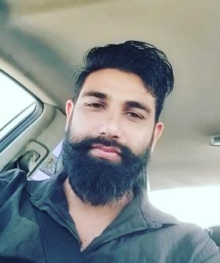

RAKESH KUMAR THALOR

**Doha – Qatar**

Mob: +974-31168820

Email: [rakeshthalor1013@gmail.com](mailto:rakeshthalor1013@gmail.com)

***Career Objectives; -***

Seeking new challenges in an organization that utilize my skills and offer opportunities for advancement, for your kind consideration I am submitting my details in below.

***Working Experience; -***

* Worked as a Heavy & Light Driver for 10 years in Doha Qatar
* Worked as a Heavy & Light Driver for 5 years in India

***Educational and other Qualification: -***

* 12th Class Passed

***Personal Details: -***

* Date of birth : 13/08/1991
* Nationality : Indian
* Marital Status : Married
* Gender : Male
* Religion : Hindu

Holding Qatari Car, Bus, Med-Truck, Trailer Driving License

***Passport and ID details: -***

* Passport No : Y6705289
* Expiry Date : 12/08/2033
* Qid Number 29135612855
* Expiry Date : 22/07/2026

***Language skills:*** -

* Arabic
* Hindi
* English

***OTHER ACQUIRED:*** -

* Ability to work under pressure
* Ability to manage problem
* Can work independently or within a team
* Leading personality
* Good character
* Excellent communication
* Good human relation

***Declaration:***

I do hereby declare that the above particulars are true and correct to the best of my knowledge and believe.

RAKESH KUMAR THALOR