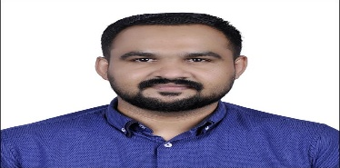**SANJU OUSEPH**

DOHA , QATAR

Mob: +974 77860499  
Email: sanjuouseph@gmail.com

**Career Objective**:

Seeking an l Driver cum Sales position in an esteemed organization where I can utilize my experience and dynamic skills for maximizing the profit of the company. To obtain a position in a supportive environment where I can help the organization grow in value utilizing my experience, capabilities and abilities.  I am having a valid visa with NOC.Having a valid Qatar Driving License.

**Summary of Skills**:

* Ability to build and maintain effective working relationship with customers.
* Proficient in Micro Soft Office, Spreadsheet and the Internet.
* Attention to detail with good communication and interpersonal skills
* Possess excellent planning, organizational and management skills
* Skilled in gathering, analyzing and presenting accurate information
* Handle responsibilities of executing basic functions including matching and entering invoices
* Flexible, highly confidential and has the ability to work in a team environment
* Handle the tasks of assisting with audit inquiries related to billing and cash receipts
* Knowledge of basic computer hardware and networking
* Ability to maintain good working relationship with coworker.
* Ability to speak in Hindi and English.
* Good interpersonal skills with the ability to work effectively with vendors and internal customers to achieve actions needed.
* Ability to work under pressure and highly competitive work environment.
* Experience of making prescribed data verification and procedural checks on accounting information
* Capability to handle large volume of work with accuracy and the ability to coordinate with different departments and outside companies.
* Self-starter and motivated.

**Educational Summary**:

Achieved Post Graduation degree in commerce (M Com)  
- Mahatma Gandhi University in the year 2011.

Achieved Graduation degree in Commerce (B Com)

- Mahatma Gandhi University in the year 2009.

**Languages:**

ENGLISH: Read, write, and speak

HINDI: Read, Write, Speak

**Personal Details:**

Name : Sanju Ouseph

Date of birth: 20.10.1988

Marital Status: Married

Nationality: Indian

Employment Status: Full Time

Visa Validity : Valid visa with NOC

License: Valid Qatar Driving License

**Passport Details:**

Passport No : M3750725

Date of issue : 12.09.2022

Date of Expiry : 11.09.2032

**Sd/-**

**SANJU OUSEPH.**