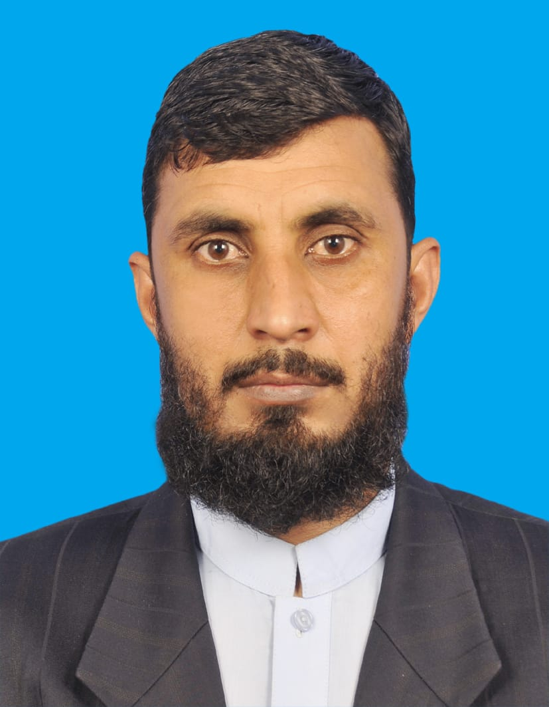 RESUME
Ubaid Ullah

Present Address: Building No 3, Opposite Al-Khalidiya Street Najma Doha Qatar.
OBJECTIVE:

To become a part of professionally well-equipped organization to utilize and explore my Knowledge (skills & abilities) and contribute in organization development accordingly.
PERSONAL INFORMATION:

Name : Ubaid Ullah
Father Name : Mulana Shahiden
Date of Birth : 10/04/1984
Nationality : Pakistani
QID : 28458606007
Passport : ET2746644
Marital Status : Married
Contact # : +97433143230
Qatar Car Driving License : Yes
Pakistani heavy Driving license : Yes
Email Id :Ubaid.ullah1258@gmail.com

EDUCATION QUALIFICATION:
1.Secondary School Certificate from BISE Peshawar 2007.
2.Higher Secondary School Certificate from BISE Peshawar2009.
3.BA from Wifaq ul Almadaris Peshawar Pakistan.

APPRECIATION AND AWARDS:
- Received appreciation letter based on excellent performance as Ground Support Equipment Operator by Pakistan International Airlines on 2nd March 2016.
- Received appreciation letter and applauded by Pakistan International Airline on short and in time completion of arrival and departure loading and unloading on 24th August 2016.
- Received appreciation letter and applauded over parking three flights PK218-354, PK736/355 and GN554/555 by PIA.

Experience:
- 8 years’ experience in Pakistan international airline as a light Drive
- Two years experience as delevery driver in Shein company Qatar.

Languages:
- Arabic
- English
- Urdu

