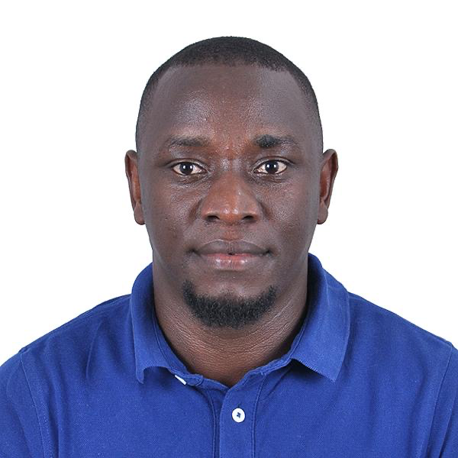 **CURRICULUM VITAE**

**BRIAN KIIZA:**

Mobile No:+256779514004

Email: [kiizabrian8@gmail.com](mailto:kiizabrian8@gmail.com)

Kampala-Uganda

Applied for: Driver

Career Objective:

Seeking suitable position allows me to utilize my creativity and experience in your reputed

Organization with opportunities for growth and self- development where I can perform

Undertaking challenging responsibilities.

**Personal details:**

Full Name : KIIZA BRIAN

Date of Birth : 04-04-1993

Sex : Male

Marital status : Married

Nationality : Ugandan

Language Known. : English

Passport Details:

Passport Number : A00734289

Date of Expiry : 31/05/2032

License Details:

* Holder of valid Qatar Driving License.

EDUCATION QUALIFICATIONS:

* Secondary school certificate (S.S.C)Pass.
* Computer certificate (……..pass).

**Work experience:**

Worked as an agent at MTN-Uganda network Communication Company for two years.

Worked as Driver at Mowasalat Company in Qatar for two years.

Worked as Valet Driver at Smart parking management (SPM) in Qatar for two years.

Worked as Driver at HireMe company in Qatar for years.

**Language spoken:**

|  |  |  |
| --- | --- | --- |
| Language | Level | Percentage |
| English | Fluent | 95% |
| Kiswahili | Fluent | 94% |
| Runyoro/Runyankole/Rutoro | Fluent | 98.4% |
| Alur/Acholi | Fair | 80% |
| Sign language | Fair | 80% |
| Luganda | Fluent | 90% |

**Knowledge and experience:**

* Driving
* Project Budgeting and planning
* Project implementation
* Good knowledge of project cycle management
* Proven experience of managing partners
* Experience with proposal writing
* Very good knowledge of settlement/camp rules and regulations
* Experience with managing budgets

**Skills:**

* Excellent management, planning, organizational and Coordination skills.
* Riding and driving skills with valid driving license.
* Proven ability to work with a range of stakeholders including civil authorities, donors and project partners.
* Good writing and reporting skills.
* Ability to work independently, under pressure and meet strict deadlines.

**Accuracy:**

* Ability to deal with conflict and crises.
* Fluency in written and spoken English.
* Ability to manage and motive a (multicultural) team.
* Ability to prepare and present issues at all levels.

**Attitudes:**

* Team player.
* Attentive to detail and result oriented.
* High integrity and initiative.
* Intercultural sensitivity, respect in dealing with other
* Willingness to travel to the field and remote locations (Flexible)

**Career Objective**

**Short term: To achieve personal growth and sustainable development.**

**Long term**

* To work towards achievement of organizational goals.
* To have greater access to advancement opportunities.
* To work towards achievement of organization’s mission.

**Hobbies:**

* Watching educative and productive movies.
* Adventure.
* Meeting new people and making friendship.
* Cooperation and Team working.

**Other Details**

**Self-Description:**

Honest, God fearing, principled and personal reserved

Flexible and willing to work and learn under minimum supervision

Keen on details and give due respect to very human being

**Strength:**

Hardworking and persistence especially in heterogeneous and complicated areas/remote area

**Declaration:**

I hereby declare that all the statements above finished by me are true

and correct to the best of my knowledge and belief

Yours Sincerely

**KIIZA BRIAN**