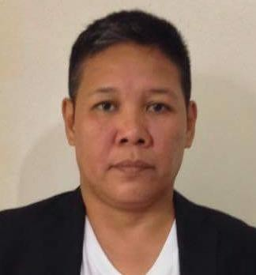
ALMERA O. ANQUE
Damortis, La union
Mobile # +97455075044
Email Address: altig7466@gmail.com

OBJECTIVE
To be able to find a position that suits my capabilities and encourages my intellectual growth; to obtain a profession that will allow me to express and hone my best potential according to my credentials and experiences.

PERSONAL INFORMATION
Date of Birth: 10 April 1974
Place of Birth: Damortis, La Union, Philippines
Nationality: Filipino
Skills: Driving (with Qatar, UAE and Philippine licenses, Computer literacy (MS Office
Applications)

EDUCATIONAL ATTAINMENT

Certificate in Electrical Installation and Maintenance Sep. 23 – Dec. 23, 2016
Regional Training Center
TESDA, Region I

Certificate in PC Hardware Servicing NCII Jun. 2014 – Mar. 2016
College of Computer Science
DMMMSU, SLUC, Agoo, La Union

WORK EXPERIENCE

Supervisor May 2000 – May 2002
St. Simon International Services, Inc.
Macban Geothermal Power Plant Bay,
Laguna, Philippines

Private Driver Sep. 2011 – 2014
Abdulla hassan Alzaabi
Abu Dhabi,UAE

Company Driver Aug. 2010 – Sep. 2011
Al WAleed Rentacar
Khorfakan, Sharjah,U.A.E.

Company Driver Jul. 2008 – Jul. 2010
Rak Transport Authority
Ras Al Khaimah, U.A.E.

Private Driver Oct. 2005 – Oct. 2007
Hamad Al Khatri

Private Driver Feb. – Dec. 2019
Sheik Sultan Saoud Abdulaziz Almualla
Sharjah, UAE

Family Driver Sep. 2021 to Present
Mohammed Khalaf A A Al-Enazi
Qatar

I hereby certify that the above information is true, and it was accomplished with utmost sincerity.

ALMERA O. ANQUE
Applicant

