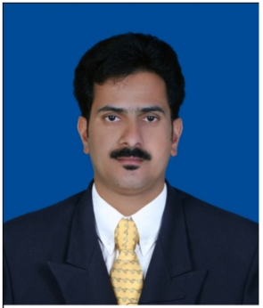
CURRICULUM VITAE

ABDU P

Mobile: +974 50371447

E-mail. abuknr58@gmail.com

APPLYING FOR: DRIVER CUM MESSENGER
Career Objective:-
A well mannered, reliable and competent driver with excellent driving skills and a thorough understanding of driving laws. Ready and qualified for the next stage in a successful career. Currently looking for a suitable position a Driver Cum Messenger in a reputable company
Educational Profile:-
■Passed SSLC in the year 1995 from Board of Public Examination, Kerala, India.
Work experiences:-
- 4Years experience oil and gas RLC project.Rassalaffan Light Driver Messenger
Manual pickup. 2023 January to january 2025 .
- FIFA world cup VVIP.VIP. Driver
2022☆
- HAMAD Medical VIP Driver.2020to2021
Designation : Driver Cum Messenger
- Duration : From 01/07/2016 to till date.
- Organization: Orange Limousine LLC, Doha, Qatar.
Responsibilities
- Transport office staff from one place to another on assigned routes.
- Pick up and drop the staff to their respective accommodations.
- Deliver and pick up documents from office to corresponding destinations and vice versa.
- Designation : Driver with Office Assistant.
- Duration : From 10/04/2011 to 30/05/2016.
- Organization : Noble Drilling (Offshore) Company LLC, Doha, Qatar.
Responsibilities:-
- Arrange offshore pass for Employees.
- To deal with new employee and fulfil their needs.
- Collect money for Electricity & Telephone bill payments of Office.
- Full responsibility of Pick & drop to Airport of each employees.
- Assist the employees in the luggage clearance from Heliport.
- Designation : Material Purchaser & Office Driver
- Duration : From 06/10/2008 to 30/03/2011.
- Organization : Specialized Building maintenance (SBMC) Doha, Qatar.
Responsibilities:-
- Purchase the materials from Local Market for Maintenance work.
- Transport staffs from one place to another on assigned work location.
- Collect Cheques from different client.
- Deliver and pick up documents from office to corresponding destinations and vice versa.
- Drop the staff to their respective accommodations after completion of the duty time.
Personal Skills:-
- Communication skills, both verbal and written.
- Excellent communication and interpersonal skills
- Fluent Hindi English, Tamil & Malayalam.
- Working Knowledge in Arabic.
- Basic Working Knowledge in Computer.
- Flexible and adaptable.
- Knowledge of safety regulations and traffic laws
- Strong driving record.
- Ability to work under pressure.
- Confident of facing the challenges and overcoming the problems.
- Ability to motivate the co workers to achieve the objective of the company.
- Strong analytical and problem solving

Personal Details:-
Nationality : Indian
Religion : Muslim
Sex : Male
Licence : Qatar Kuwait, and India
Marital Status : Married
Languages Know : English, Hindi
Arabic Malayalam Tamil
Visa Status : Transferable Visa.
Passport No : V7103001

Declaration:-

I hereby declare that the above furnished details are true to the best of my knowledge and belief.
Sincerely
Abdu. P

