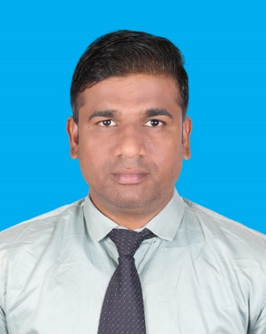  CAREER OBJECTIVE  Hardworking and reliable Valet Driver with excellent driving and customer service records. Available evenings weekends and holidays on short notice. Able to work well independently or as part of a team of valet drivers.  SKILLS  TECHNICAL EXPERTISE  MS Office  - Internet Explorer  LANGUAGES  - English  Arabic  - Hindi  - Malayalam  - Telugu  PERSONAL DETAILS  Nationality : Indian  Passport No. : U7467460  Marital status : Married  LICENSE DETAILS  QATAR :29035644359  OMAN : 93814677  INDIA : TS01020160022364 | SYED KHALEEL  LIGHT DRIVER  (+974)30851915 | khaleelsyed2626@gmail.com  EXPERIENCE  (2022-2025)  VALET DRIVER  MAWAQIF QATAR.  - Carefully drove and parked guest vehicles without causing traffic damage or obstruction.  - Ensured guest vehicles were locked and secure.  - Reported unusual events to management and security personnel.  (2019 – 2022)  HOUSE DRIVER  DOHA, QATAR  - Driving family members to their destinations, ensuring punctuality, and keeping the car clean and in good working order through regular checks and maintenance.  (2015 – 2019)  VALET DRIVER  MARRIOTT, HYDERABAD  - Parked and drove vehicles to and from lobby and garage.  - Coordinated all activities with senior security personnel.  - Assisted with transport operations tasks as required.  (2013-2015)  COMPANY DRIVER  TM TECH TRADING LLC, OMAN  transporting various materials, tools, and equipment to and from construction sites, ensuring that projects have the necessary resources to proceed without delays.  EDUCATION  SECONDARY EDUCATION 2006  ST. ALBANS HIGH SCHOOL, SECUNDERABAD

