NISSAR THOTTAPPIL RAMALAN
LIGHT DUTY DRIVER/
MESSENGER

Doha Qatar



nisarneji1982@gmail.com Passport No. Validity: 28-01-2031

- With more than 20 years of driving experience in the State of Qatar, Oman, and Bahrain, demonstrating strong commitment to passenger safety and comfort. Knowledge of traffic rules, regulations, and safe driving practices
  - Experienced in operating Cars, Vans, mini trucks, and minibus.
  - Ability to navigate using maps
  - Ability to perform minor maintenance tasks
  - Good communication skills
  - Punctual and reliable in duties assigned.
- Qatar - 26-05-2026
- Oman - 28-12-2026
- Bahrain - 19-10-2027

- Kerala Board of Secondary Education (+2)
- Secondary School Leaving Certificate (S.S.L.C)

2022-2023
Noor Birds Shop, Bahrain. Position: Salesman

2020-2021
C.P.B Fruits and vegetables, Qatar.
Position: Salesman/Employee transportation

2016-2018
Coffee Center, Oman
Position: Salesman/Store Driver

2004-2015
C.P.B Fruits and vegetables, Qatar, Oman. Position: Salesman/Employee transportation

05/04/1982
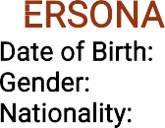
Male
Indian

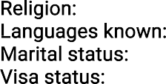
lish, Arabic, Hindi, Malayalam, Tamil
Muslim
Eng Married
Valid QID

I herby confirm that the details mentioned above are true to the best of my knowledge.

Nissar Thottappil Ramalan 05-03-2024
Doha Qatar

