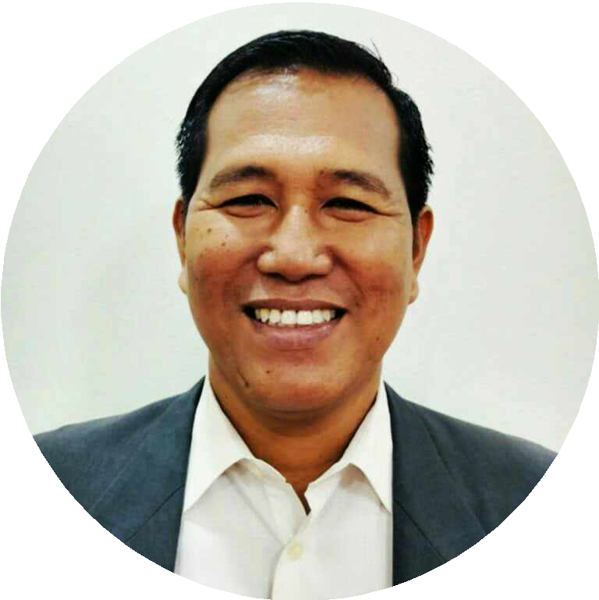
CONTACT

Address: Philippines

Phone
 +63 955 127 9494

 Email: robinsonjrcarmesis44@gmail.com

EDUCATION

New Era University, Philippines
1996 - 2000

SKILLS

- Forklift Operation
- Heavy Equipment Operation
- Truck Driving
- Safe Telehandler Operation
- Bobcat Operation
- Dump Truck Operation
- Steam Boiler Operation
- Company Driving
- Safety Awareness
- Equipment Maintenance
- Regulations Compliance
- Communication
- Problem-solving
- Time Management
- Attention to Detail

ROBINSON V. CARMESIS JR.

PROFESSIONAL SUMMARY

A versatile and safety-conscious professional with extensive experience as a forklift operator, jeepney driver, heavy equipment operator/truck driver, and company driver. Skilled in operating a wide range of machinery, including forklifts, telehandlers, bobcats, dump trucks, and steam boilers, with a strong focus on safety and efficiency. Possesses a proven track record of reliability, adherence to regulations, & effective communication. Eager to leverage diverse experience and expertise to excel as a forklift operator, contributing to the smooth & efficient operation of warehouse or construction environments.

WORK EXPERIENCE

Self-Employed, Philippines Jeepney Driver
2019 - Present
- Ensured safe and efficient passenger transportation.
- Maintained cleanliness and orderliness of the jeepney.

Sta. Clara International, Qatar Forklift Operator
2015 - 2018
- Expertly operated forklifts in warehouse environments.
- Loaded and unloaded goods from trucks and storage areas.

Self-Employed, Philippines Jeepney Driver
2012 - 2015
- Collected fares and issued tickets to passengers.
- Adhered to traffic regulations and safety guidelines at all times.

Spectrum Solution, Kingdom of Saudi Arabia Heavy Equipment Operator / Truck Driver 2012
- Managed heavy equipment such as trucks and dump trucks.
- Transported materials and equipment to and from construction sites.

SOMI Qatar Erection and Engineering, MESAIEED Power Plant, Qatar Safe Telehandler Forklift / Bobcat Driver / Dump Truck Driver
2009 - 2011
- Safely operated telehandlers, bobcats, and dump trucks.
- Loaded and unloaded materials at construction sites.
- Followed safety procedures and guidelines to prevent accidents.

YU YIN Paper Mills, Chiayi, Taiwan R.O.C
Heavy Equipment Driver / Steam Boiler & Marquip Operator / Forklift Operator 2007 - 2009
  - Conducted pre-trip inspections & routine maintenance on heavy equipment.
  - Adhered to traffic regulations and safety guidelines on public roads.

ACE Hardware Builders Center, Philippines Company Driver
2003 - 2006
  - Provided transportation services to company personnel, clients, or guests.
  - Ensured the safety and comfort of passengers during transit.

TRAININGS AND CERTIFICATIONS

  - Heavy Goods Vehicle Driving License from Philippines
  - Qatar Light Vehicle Driving License
  - Bahrain Heavy Equipment Operator License

