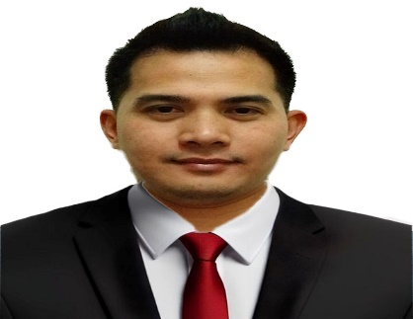
Al Khubaib Street 25 zone 6 Bldg.
Dessert Star Residences Doha Qatar
WhatsApp number: +97455471825
Mobile number: +97455471825
Passport number: P9994963A
Email: nepdelizo@gmail.com
NEPTALI L. DELIZO

OBJECTIVE | To be part of a stable and well managed organization where my knowledge and experienced can be made available for the realization of company’s goals and objectives.
SUMMARY OF QUALIFICATION | - Over 7 years of working experience in different companies as Salesman/Sales Staff and Officer in Charge.  - Have a genuine interest in other people and willingness to help and assist customers. Established good working relationships with customers/clients and service experience.  - Ability to organize, prioritize and work under extreme work pressure, heavy work load and deadlines.  - Experience in Sales in mall, supermarket, groceries, gadgets and accessories.
EXPERIENCE | Al Jazeera Trident Trading (MUMUSO Qatar)  Al Sadd Street Doha, Qatar  Salesman  March 20, 2025 – Present  Ansar Gallery Group Companies  Barwa Commercial Avenue Abu Hammour Doha Qatar  Sales Man  September 21, 2022 – April 21, 2025  Danube Co. For FoodStuffs & Commodities (K.S.A)  Hayat Mall, King Abdullah St. with King Abdul Aziz  St. Intersection,Al Morsalat Riyadh (K.S.A)  Sales Man  June 21, 2017 – July 07, 2019  - GameXtreme (Vismay Int’l Incorporated)  Bldg. 2 Sunyu Compound Veterans Center Taguig City  Officer in charge/ Sales staff  March 18, 2015 – June 03, 2017
SKILLS  &  ABILITIES | - Strong product knowledge and understanding of customer needs.  - Verbal communication skills and Greeting customers.  - Handle refund & exchange items by Customers.  - Can do multitasking and willing to be trained.  - Computer Literate
PERSONAL  DATA | Date of Birth September 09, 1986  Place of Birth Mandaluyong City Medical  Center  Sex Male  Citizenship Filipino  Marital Status Single  Height 5 ft 8 inch  Weight 79 kgs  Religion Christian  Language spoken & written English, Tagalog & Arabic  Contact person in case of emergency  Genevieve M. Gono  +639271497148
EDUCATION | Rizal Technological University  Boni Avenue Mandaluyong City  Bachelor of Science in Chemistry  2004 – 2009  Jose Fabella Memorial School  Acacia Lane, Mandaluyong City  High School Diploma  1999 – 2003  Andres Bonifacio Elementary School  Acacia Lane, Mandaluyong City  Elementary Diploma

I hereby certify that the above information given is true to my personal knowledge.

___________________
Neptali L. Delizo Applicant

