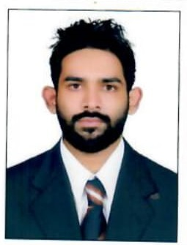  SABEEH M  MALENANDIYIL(HO)  VISHNUMANGALAM(PO)  KALLACHI (VIA)  KOZHIKODE-673506  KERALA  INDIA  E-mail  sabeehmk916@gmail.com  Phone  +91 8086102002  Personal Details  Date of Birth  10th January 1993  Gender  Male  Nationality  Indian  Religion  Muslim  Marital status  single  Languages  English,Malayalam,Arabic |  | CURRICULUM VITAE  Career Objective  To build a successful career by working in a promising, creative and challenging environment where I can apply my knowledge and experience to the best of my ability, thus contributing towards organizational goals and the progress of the organization, along with personal development.  Education  - Bcom  Calicut University-2013  - 12th Standard with aggregate of 70% from Higher Secondary Board of Public Examination by the Government of Kerala State, India - 2011  - SSLC with 80% from Board of Public Examination by the Government of Kerala State, India – 2009  Technical Qualifications .  - Specialized in Excel, Tally ERP 9.0and Peachtree accounting software  - Knowledge in computer fundamentals, Windows XP, Windows 7, Linux.  License Details  - Qatar Valid License  License No:542018566459  Strengths  - Practice in both manual and computerized accounting.  - Accounting activities up to finalization of accounts.  - Maintenance of various accounting registers for Purchases and Sales.  - Computerization of accounts using Tally 9.  Declaration  I hereby declare that the above mentioned details are true and correct to the best of my knowledge and belief.  21/11/2018  Calicut SABEEH M K

