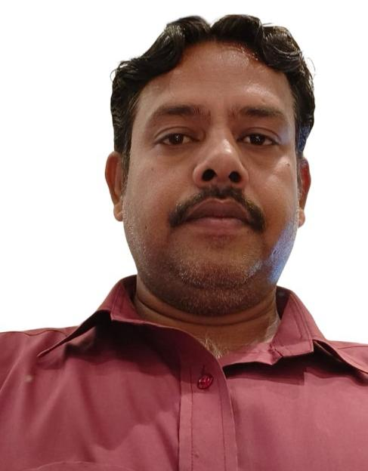
MD. TAUSIF

PROFILE
Professional driver with over 11 years of experience operating light and medium vehicles. Proven ability to ensure safety, punctuality, and vehicle maintenance. Experience includes 4 years in Jaynagar, Bihar, and 7 years in Qatar with valid residency and passport.

PROFESSIONAL EXPERIENCE
- Driver
Jun 2014– May 2018
PO&PS Jaynagar, Madhubani, Bihar
• Safely transported passengers and goods within local areas.
• Maintained vehicles in top condition and adhered to all road safety rules.
- Driver
Jun 2018 – May 2025
Qatar
• Worked for private and company clients ensuring safe and timely transportation.
• Performed regular maintenance, inspection, and basic repairs of vehicles.
• Demonstrated excellent route knowledge and time management.

PERSONAL INFORMATION
Name: MD. Tausif
Date of Birth: 01/01/1984
Passport No: R6520642
Passport Issue Date: 04/01/2018
Passport Expiry Date: 03/01/2028
Place of Issue: Patna, India
Qatar ID No: 28435650864
Qatar ID Expiry: 06/07/2026
Address: Village Baldiha, PO&PS Jaynagar, Madhubani, Bihar, India
Nationality: Indian
Marital Status: Married
Language: Hindi, English
Experience: 11 years total (4 years India + 7 years Qatar)

