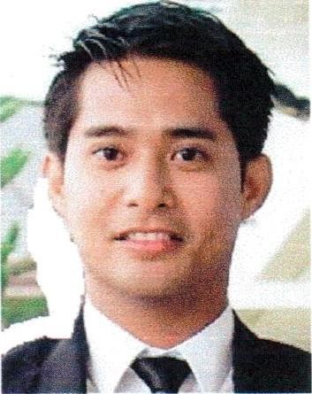





Al Mansoura, Doha, Qatar

+97431224142 / +974 3309071

ryan10aguilar@yahoo.com
DL No. 28360806903

Married

SKILLS
Ability to supervise staff.
Communication and interpersonal skills.
Computer and software skills - Finance and accounting literacy.
Knowledge of applicable laws and regulations.

EDUCATION / TRAINING

Bachelor of Science in Criminology - Major In Law

PMP (Project Mngt. Professional)
Leadership Training
ICON Training center

CSCA – Certified Supply Chain Analyst – Udemy Certification

NEBOSH International General Certification (IGC)
IOSH Managing Safely (MS)

Automotive and Land transport course
Fire Warden Course

Questioned Documents Examination Training
Narcotics and Drugs Relation Ballistics and Criminal
Investigation Support Falsification of Documents Investigation

Ryan Gregor Aguilar

Fleet Operations Coordinator
Highly motivated, fleet professional seeking a management role with Al Abdulghani Motors (Toyota) - Qatar. Collaborative team leader with seven years of experience as a fleet specialist and compliance management. Result driven negotiator motivated to reduce business costs while maintaining positive client relationships.
PROFESSIONAL EXPERIENCES

OPERATIONS COORDINATOR
2018 – the present
Employer: Al Abdulghani Motors (Toyota) - Doha, Qatar
Oversee vehicle maintenance, repairs, and inspections to ensure fleet safety and efficiency.
Coordinate vehicle assignments, scheduling, and meet operational needs.
Using SAP System to generate reports on fleet performance, safety, and compliance, and analyze data to identify areas of improvement.

BUSINESS DEVELOPMENT EXECUTIVE
2016 – 2018
Employer: Doha Industrial Safety Services - Doha, Qatar
Research and identify potential clients, markets and partnership to drive business growth.
Identify and pursue new sales opportunities, negotiate deals, and drive revenue growth.
Conduct market research, analyze industry trends, and identify opportunities for growth and expansion.

OPERATIONS CONTROLLER
2015 – 2016
Employer: Challenger Limousine Rent a Car – Doha, Qatar

FLEET SERVICE ADVISOR
2013 – 2015
Employer: Europcar Dubai LLC – Dubai, UAE

MARKETING AND REAL ESTATE OFFICER / OFFICE CORDINATOR
2008 – 2012
Employer: Century Properties Group Inc.

QUALITY CONTROL INSPECTOR
2006 – 2008
Employer: TSTech Trim Philippines – Techno Park, Laguna, Philippines

