CURRICULAM VITAE

Name-RAVNEET
VILLAGE LAMBRA 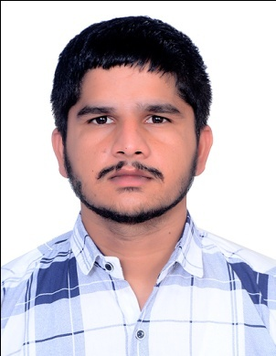
DISTT JALANDHAR 144026
Mob. : +91 9877537192
Email Id: - ravneetsheanmar04@gmail.com
Career Objective:
To perceive a career in a renowned firm with dedicated efforts and to associate myself with an organization that gives me a chance to update my knowledge.
Educational Qualification:
I have done 3 years diploma in automobile engineering from ct polytechnic college Shahpur Jalandhar. I have completed my diploma in May 2017.
Secondary Education
I have done my secondary education in +12 arts from senior secondary school village lambra Jalandhar in 2014.
ACADAMIC QUALIFICATION :
S.NO. | QUALIFICATION | BOARD/ INSTITUTE | YEAR OF PASSING | DIVISION | PERCENTAGE
1. | Diploma automobile engineering | P.S.E.B | May 2017 | 1st | 68
2. | 10+2 | P.S.E.B | May 2014 | 1st | 60%
TECHNICAL QUALIFICATION
- Basic Computer knowledge
- Computer Skills:
- Data Operations
EXPERIENCE
- I have 2 Years work experience in RAVI MOTOR GARAGE.
- I have also 3 years work experience in TRIOLET BUS SEVICE LTD [MAURITIUS].
- Now I am working in AUJLA MOTOR since 1 year.
STRENGTH & SKILLS:
- Communication Skills.
- Ready to take responsibility.
- Quick Learner
- Good Interpersonal Skills
- Punctuality
- Self learner
- Positive Thinking.
- Hardworking
PERSONAL INFORMATION
Name : Ravneet
Father Name : Mr. Balbir Kumar
Mother name : Sulinder kaur
Date of Birth : 20/08/1996
Language Known : English, Punjabi, Hindi
Marital Status : Single
PASSPORT DETAILS
Passport No. : P7594960
Passport Issue date : 17/03/2017
Passport expiry date : 16/03/2027

