Sales & Customer Service
Faycel Gueriachi
Doha Qatar. Faycelguer@gmail.com +974 7106 4662
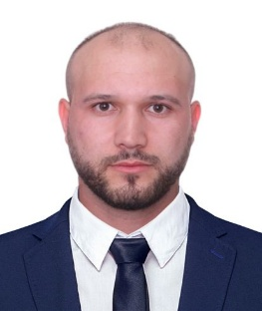
Summary:
Luxury Retail and Guest Service professional with 9 years of experience in high-end fashion and premium customer service environments. Proven track record working with international luxury brands such as Delvaux Dubai and Radley London, as well as Guest Service Representative experience at Vendôme Mall Qatar. Highly skilled in clienteling, personalized service, sales target achievement, and delivering exceptional customer experiences in multicultural settings. Recognized for professionalism, strong communication skills, and the ability to build long-term client relationships while representing luxury brand standards.
Experience:
Guest Service Representative 2024-2026
Vendôme Mall Doha Qatar.
- Greeting Vvip guests and providing personalized tours in the mall and luxury brands
- Resolve customer complaints efficiently, achieving a 96% satisfaction rate in post-service surveys.
- Handle lost and found services, maintaining accurate logs and facilitating item returns.
- Assist mall management with promotional activities by distributing flyers and guiding customers to participating stores.
- Answering and receiving phone calls from customers
Luxury Sales Representative 2020-2024
Delvaux Dubai Mall United Emirates Arabic
- Delivered personalized luxury customer service in line with brand standards
- Provided detailed product knowledge on leather goods and accessories
- Built and maintained relationships with VIP and returning clients
- Achieved individual and store sales targets
- Handled POS transactions and after-sales services
- Maintained boutique presentation and visual merchandising standards
Sales Associate 2017-2020
Radley London Algiers Algeria
- Provided premium customer service in a luxury fashion retail environment
- Promoted handbags and accessories through consultative selling
- Met daily and monthly sales KPIs
- Managed POS systems, payments, returns, and exchanges
- Supported stock control and store operations
Education:
Third year of secondary school Foreign Languages 2017
Skikda Algeria
Skills:
Luxury Retail Sales/Guest Services and Customer Relations/Clienteling and VIP Service/Upselling and Cross-selling/POS Systems/Sales Target Achievement/Communication and Interpersonal Skills/Multicultural Environment Handling
Languages:
Arabic (Native) English (Fluent) French (Fluent) Spanish (Basic)

Additional Information :
Valid Qatari driving license – Category B

