Contact
Whatupno
+91 9014685219
Warehouse Worker/Packer
5+ Years of experience as a Driver Worker and Packer. Seeking a career that allows me to utilize all my skills knowledge in the field of customer service & warehouse. Also I have many years of experiences as a Assistant Front Office Manager, Housekeeping Supervisor, Floor Supervisor and many more, but now i want to move as a warehouse worker for better opportunity.

Work Experience

Date of Birth

DRIVER QATER

01/01/1975
Email
alfaizaent@gmail.com
Address
SHALIBANDA HYDERABAD,INDIA

Education
Diploma Matriculation (10th)

Skills
Receive and count inventory items, then record the data manually or electronically on the computer.
Pack or unpack items to be stocked on shelves in stockrooms, warehouses or storage yard.
Verified inventory computations by comparing inventory reports to physical stock and investigating and reporting any discrepancies and correcting errors.
Stored and organized items in an accessible manner in warehouses, supply rooms, and other relevant areas.
Entrusted with the proper labeling of stock merchandise using identification tags, state-issued tobacco stamps, electronic marking tools, and other labeling equipment.

Organizational Skill
Time Management

DRIVER OMAN
Unloading incoming material from trucks, by opening crates, boxes, cartons, or bags and

DRIVER
Replacing
DELAVERY
Communication
Stocking material in the correct labeled areas such as shelves, cabinets, racks, and drawers. Hand deliver parts to the requesting location when forklifts, hand carts, or jack pallets are not available.








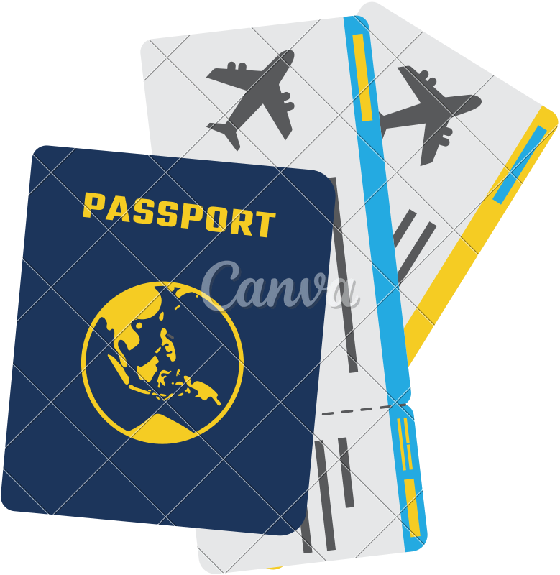

Language
English Hindi
ARABI
Receiving detailed instruction on work to be accomplished and make decisions within the framework of the prescribed procedures, such as which work area is using a particular item and which bin or rack will be most convenient for the storage.
Passport Details
14/06/2017 13/06/2027

