NAME:KEVIN NJOROGE NYOIKE
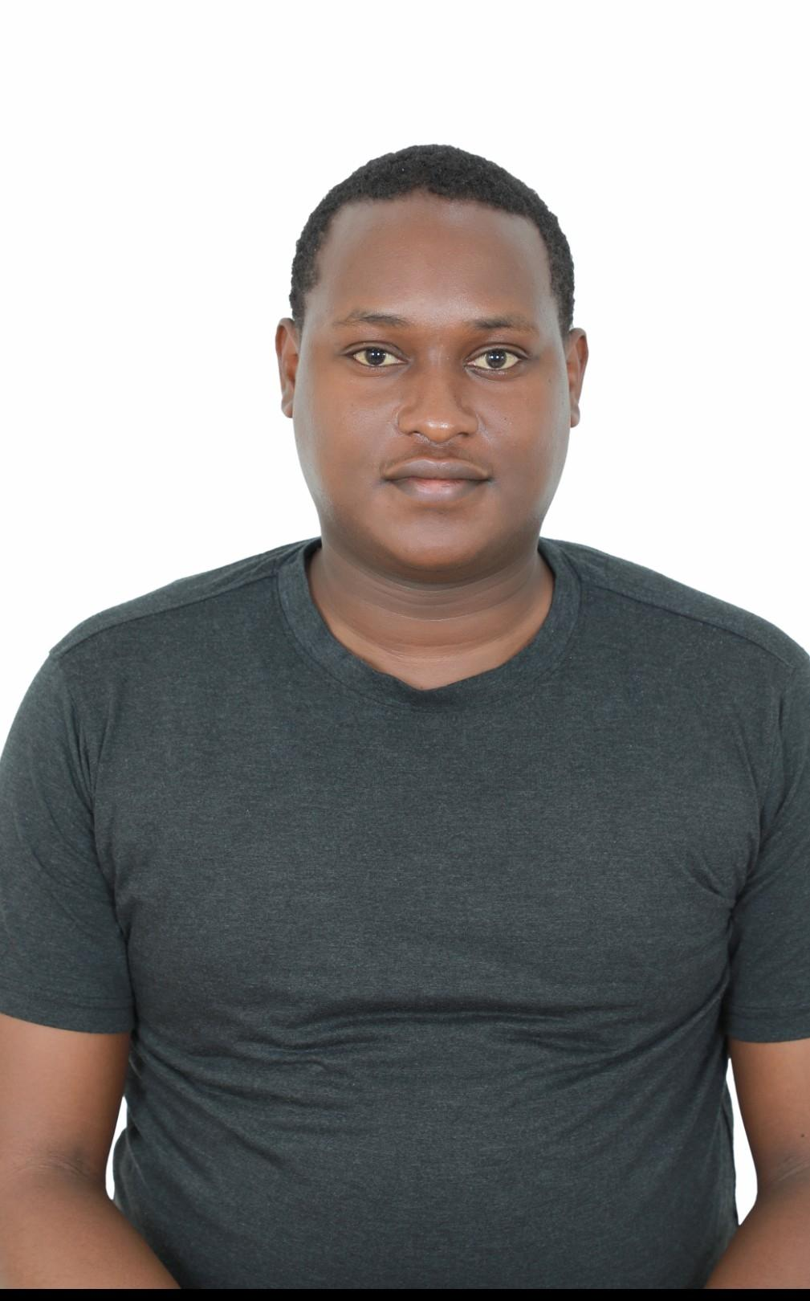

Contacts:
Mobile: 66602637
Email: itznjoro@gmail.com

PERSONAL DETAILS:
Date of Birth: 24 October, 1998
Nationality: Kenyan
Gender: Male
Languages: English

WORK EXPERIENCE
2024-2026
ALWADI HOTEL.
MANDARIN ORIENTAL.
I worked as a valet diver at alwadi hotel then later worked as a hotel driver at mandarin Oriental.

CAREER OBJECTIVE .
To work on ambitious assignment in a stimulating environment that nurtures creative professional growth while being resourceful, innovative and flexible, thereby optimizing corporate profitability and adhering to the corporate philosophy.
STRENGTHS:
Hard working .
Problem solver.

Alwadi hotel:2024-2026
Welcome the customers and Park their vehicles upon arrival and issue them with a parking ticket.

RESPONSIBILITIES
Mandarin:2026 till date
Pick guests from the airport to the hotel.
Take guests to all beautiful sceneries of Doha and the rest of the country.

